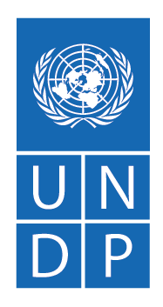
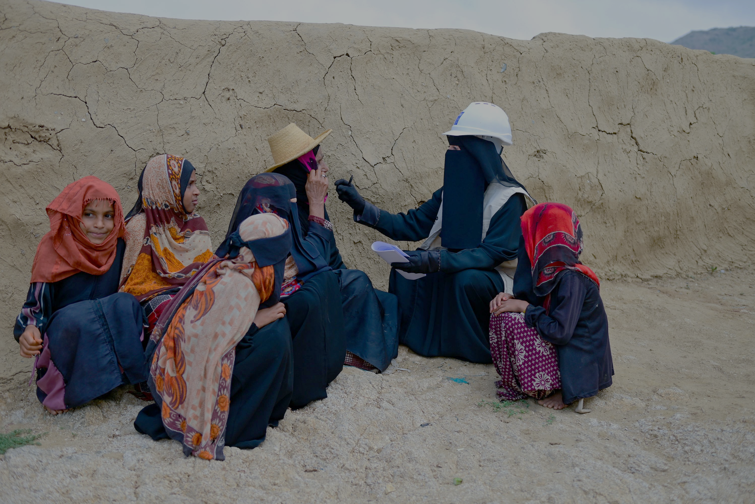

BI-ANNUAL PROGRESS REPORT
(1 July 2024 – 31 December 2024)

EMERGENCY SOCIAL PROTECTION ENHANCEMENT AND COVID-19 RESPONSE PROJECT (ESPECRP/IDA D762-RY, E006-RY, E1640-RY)

ABBREVIATIONS AND ACRONYMS
AF  BA  BC  CC  CBY  CfW  CfN  CHE  DFA  ESAP  ESMF  ESMP  ESPECRP  ESRM  GB  GBV  GM  HH  IDA  IDPs  IFPRI  IRG  IPs  ISM  LTA  MIS  MFIs  OHS  OTP  PAD  PDO  PF  PFI  PSEA  PGM  PWP  RVM  SFD  MSME  SMED  SMEPS  SWF  TA  TFC  ToR  TPMA  UNDP  US$  WB  YER  YLG | Additional Financing  Business Association  Business Cooperative  Community Contracting  Central Bank of Yemen  Cash for Work  Cash for Nutrition  Community Health Educator  De-Facto Authorities  Environmental and Social Action Plan  Environmental and Social Management Framework  Environmental and Social Management Plan  Emergency Social Protection Enhancement and COVID-19 Response Project  Environmental and Social Risk Management  Geobundling  Gender-Based Violence  Grievance Mechanism  Household  International Development Association  Internally Displaced Persons  International Food Policy Research Institute  Internationally Recognized Government of Yemen  Implementing Partners  Implementation Support Mission  Long Term Agreement  Management Information System  Micro Finance Institutions  Occupational Health and Safety  Outpatient Therapeutic feeding Program  Project Appraisal Document  Project Development Objective  Parent Fund  Partner Financing Institution  Prevention of Sexual Exploitation and Abuse  Portfolio Guarantee Model  Public Works Project  Remote Verification Mechanism  Social Fund for Development  Micro, Small and Medium Enterprise  Small and Micro Enterprises Development  Small and Medium Enterprise Promotion Services  Social Welfare Fund  Technical Assistance  Therapeutic Feeding Center  Terms of Reference  Third Party Monitoring Agency  United Nations Development Programme  United States Dollar  The World Bank  Yemeni Riyal  Yemen Loan Guarantee
Contents
1. Executive Summary 4
2. Major Events 5
3. Progress of Project Development Objectives (PDOs) 6
4. Financial management and disbursement status 8
5. Progress by Subcomponent 10
5.1 Subcomponent 2.1 Cash for Nutrition (CfN): 10
5.2 Subcomponent 2.2 Cash for Work (CfW) 14
5.3 Subcomponent 2.3 Community Assets (CA) 18
5.4 Subcomponent 2.4: Economic Opportunities and Food Market Resilience 22
5.4.1 Subcomponent 2.4a Increased Access to finance for MSMEs 22
5.4.2 Sub-comp 2.4b Direct support to MSMEs and Business Associations in Critical Sectors: 25
6. Component 2 Project Management, Monitoring, Evaluation and Capacity Building of National Institutions 26
7. Monitoring and Evaluation 28
8. Social and Environmental Risk Management (Detailed report in this link) 33
Environmental and Social Plans and Risk Assessments 34
9. Communication & Visibility Plan 43
10. Key Actions/Activities for the Next Reporting Period (January to June 2025) 44
11. Risk Framework and Risk Mitigation Measures 46
12. ANNEXES: 49
Annex 1: Results Framework 49
Annex 2: Annual Progress (Expenses and Direct Beneficiaries) per Subcomponent 52
Annex 3: ESPECRP ISM 29 – 31 October 2024: Actions and Status of Progress 53
Annex 4: Communication and Visibility Reference Links 55

Executive Summary

This bi-annual report provides an overview of the physical and financial progress of the Yemen Emergency Social Protection Enhancement and COVID-19 Response Project (ESPECRP) for the period from July 1 to December 31, 2024. The report highlights progress against the Results Framework (RF) and disbursement status cumulatively since the inception of the project. It summarizes major events encountered within the second half of 2024, the project risks and key challenges under each subcomponent. The report also provides updates on Environmental and Social (E&S) safeguard matters, institutional capacity building, procurement, as well as the planned deliverables for the next reporting period.
The Project Development Objective (PDO) aims to provide cash transfers, temporary employment, and enhanced access to basic services for food-insecure populations impacted by COVID-19, conflict, and climate-related shocks, while also strengthening national institutions. The additional finances introduced a ‘continuum of support’ approach with geo-targeted interventions to tackle food insecurity and malnutrition, known as ‘Geobundling’. The parent financing agreement (PF) of ESPECRP, signed on December 23, 2020, allocated a total grant of US$ 61.4 million. This was followed by an Additional Financing (AF) agreement of US$ 108 million on April 13, 2022, and a second additional financing (AF2) of US$ 63.5 million on March 30, 2023. The project closing date has been extended to December 31, 2026. The project is implemented by UNDP through three national institutions defined as the Implementing Partners (IPs): the Social Fund for Development (SFD), the Small and Micro Enterprise Promotion Service (SMEPS), and the Public Works Project (PWP).
During the reporting period, the project achieved significant progress despite the challenging operational context. Activities under the Parent Financing were successfully completed, with only around half a million US dollars remaining for UNDP management activities. The Additional Financing (AF) advanced substantially following the clearance of numerous safeguard plans for civil works under Cash for Work (CfW) and Community Assets (CA), achieving over 56 percent in disbursement. For AF2, subdistrict needs assessments were completed, and most sub-projects identified, with safeguard plans scheduled for submission and implementation set to begin in the first quarter of 2025.
Cumulatively, since inception, the project has reported a total disbursement of 55.16 percent across all financing agreements. Under the Results Framework (RF), the project has exceeded its target for nutrition-sensitive cash assistance, reaching over 126,700 households (119 percent of the target), engaged more than 92,700 direct workers in short-term employment (59 percent of the target), and supported over 7,800 Micro, Small, and Medium Enterprises (MSMEs) with grants and technical assistance to enhance food production. The project has maintained compliance with environmental and social safeguards while addressing challenges such as delayed approvals and restricted access in the North, alongside notable progress in strengthening the institutional capacity of IPs. Persistent challenges, including bureaucratic obstacles in the North, the designation of the Houthis as a terrorist organization by the USA, and ongoing banking issues, have contributed to disruptions and delays in implementation. These challenges were managed through active negotiations, close monitoring, enhanced community engagement, and adaptive measures to ensure continuity and effectiveness.
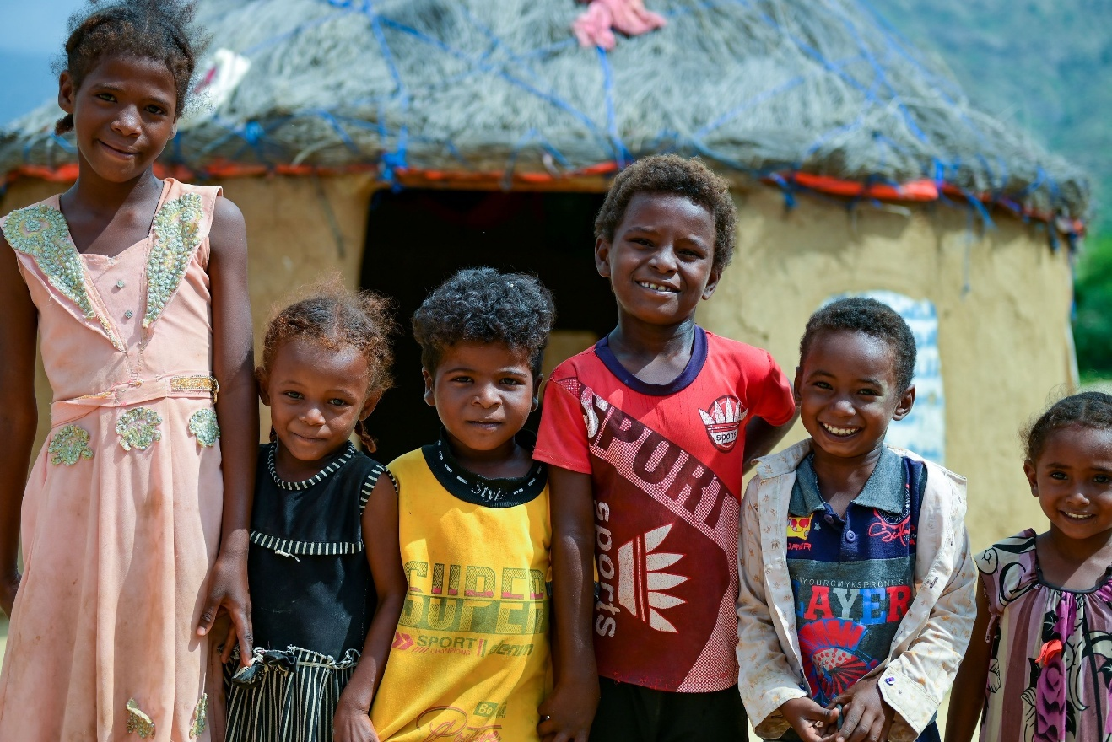
Despite these complexities, ESPECRP has made substantial progress in addressing food insecurity, improving livelihoods, and fostering community resilience. Moving forward, the project emphasizes enhanced coordination, streamlined approval processes, and sustained capacity-building efforts to maximize impact and ensure long-term sustainability.

Major Events

New Government by the De-Facto Authority (DFA): In August 2024, the Houthi-led Supreme Political Council in Sana’a announced the formation of a new government, officially named the "Government of Change and Construction". The restructuring involved abolishing three ministries, merging eight others, and appointing new ministers. The oversight of SFD and PWP has been assigned to the Ministry of Social Affairs and Labor (MoSAL) and the Ministry of Local Administration (MoLA) respectively, posing potential risks to the impartiality status and country wide reach capacity of these two national institutions.
In response, SFD has communicated with its partners and the new government, receiving official assurances that SFD's independence will be respected according to its establishment law. PWP has discussed arrangements with the new government to maintain its independence, too. Additionally, the duties and oversight functions of the Supreme Council for the Management and Coordination of Humanitarian Affairs (SCMCHA) have been transferred to the Ministry of Foreign Affairs (MoFA). The latter has provided assurances to UN agencies for stronger cooperation, though the adjustment process requires time.
Escalations between the DFA and Israel: The DFA in Sana’a has intensified its military attacks in the Red Sea and against Israel, with an announced intention to force Israel to stop its ongoing aggression in Gaza. In retaliation, Israel conducted multiple airstrikes targeting military sites and strategic infrastructure across DFA areas.
There are fears that a continuity of escalations will exacerbate the humanitarian crisis in Yemen and pose geopolitical consequences and heightened security risks in the region. Although the project implementation is not affected at this time, there is a need to conduct regular risk assessments and scenario planning and be ready to adapt operational plans when needed.
Implementation Support Mission (ISM): The WB conducted an ISM with UNDP and IPs for ESPECRP from October 29 – 31, 2024 in Amman, Jordan. The objectives of the mission were to assess project implementation progress, including a review of (i) overall progress by component, the Results Framework (RF); (ii) compliance with the project’s fiduciary (financial management, disbursement, and procurement) and Environmental and Social Framework (ESF) requirements in line with the Project’s Environmental and Social Commitment Plan (ESCP); (iii) findings of the latest Third-Party Monitoring (TPM) report and outcomes; and (iv) review and update overall project implementation risks.

The mission undertook a review of implementation progress of the geographically targeted development interventions under the project. The mission acknowledged that the project continues to make strong progress against a highly volatile political and security backdrop. The project’s performance is rated as Satisfactory for environmental and social (E&S) risk management, Moderately Satisfactory for financial management (owing to the fragile and high-risk of operating in a conflict-affected country), and Satisfactory for procurement. All project components are rated Satisfactory.

The agreed actions along with the updated status of each are summarized in Annex 2, and the aide memoire and ISM presentations in this link.

Progress of Project Development Objectives (PDOs)
As of 31 December 2024, since the inception of the project, the project achieved significant progress towards the 1st PDO (Number of beneficiary households benefitting from the cash for nutrition (CfN), reaching 126,726 households (HHs) (representing 119 percent of the total target) with nutrition-sensitive cash assistance and awareness sessions. This included 8,146 households from the Social Welfare Fund (SWF) against a target of 9,300. Beneficiaries comprised 136,798 women (122.6 percent of the target) and 200,209 children (130.9 percent of the target). To meet the overwhelming demand for CfN in target communities, the project adjusted the benefit duration from 12 to 6 months for most beneficiaries, with the exception of women with malnutrition who continue to receive the full 12-month cycle. This adjustment allowed the project to extend support to a larger number of households, resulting in the indicator exceeding its target.
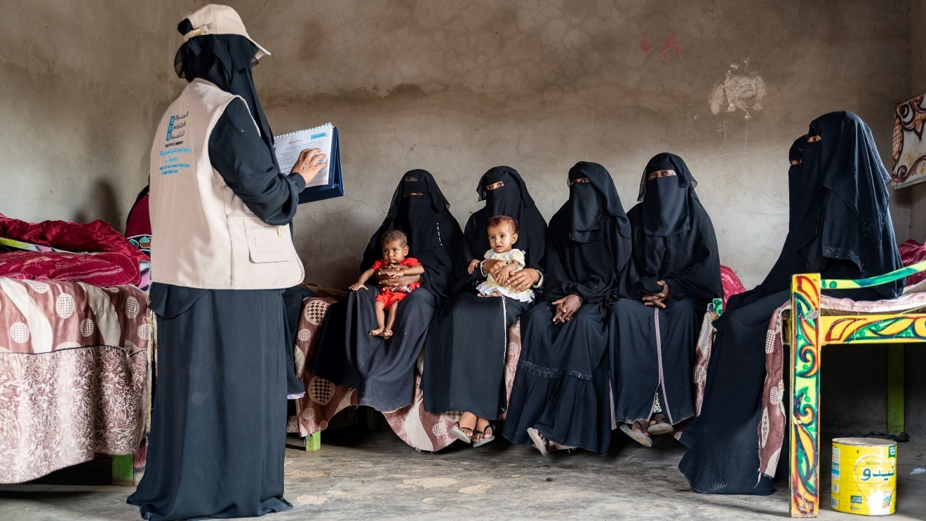
Under the 2nd PDO (Number of direct beneficiaries of wage employment), the project supported 92,718 direct workers, achieving 59.7 percent of the total target. This included 25,228 women workers (74.9 percent of the target of 33,710) and 8,262 Internally Displaced People (IDPs), representing 37.1 percent of the target of 22,281. Progress under this PDO improved during the reporting period due to the clearance of Environmental and Social (E&S) safeguard plans and enhanced operationalization of the geobundling approach.
The project also made substantial progress under the 3rd PDO (Number of people with access to basic services and Number of Micro, Small, and Medium Enterprises (MSMEs)). It reached 957,879 people (85.3 percent of the total target) with improved access to basic services, with women constituting 50 percent of the beneficiaries. Among these, 103,030 people (37.8 percent of the revised target) gained access to improved sanitation services, addressing water-borne diseases exacerbated by climate change.
In supporting MSMEs, the project achieved 78.1 percent of its target, benefiting 7,819 out of 10,009 planned MSMEs. This included 1,754 women-led MSMEs (63.2 percent of the target). Progress in women-led MSMEs improved due to targeted measures, such as expanding the scope to include all women income-generating activities, increasing loan coverage to encourage microfinance institutions to lend to more women, and enhancing engagement through awareness and follow-up efforts.
The table below presents the PDO-level progress against the total target, while Annex 1 provides a detailed Results Framework (RF) at the intermediary levels for each subcomponent.

Table 1: ESPECRP PDO Progress as of 31 December 2024

PDO Level Indicators | Total Target | Progress as of 31 Dec. 2024 | %
PDO One: Provision of Cash Transfers  Number of beneficiary households benefitting from the cash for nutrition program | 106,500 | 126,726 | 119%
Number of beneficiary households (SWF) | 9,300 | 8,146 | 87.6%
Number of beneficiaries (women) | 111,600 | 136,798 | 122.6%
Number of beneficiaries (children) | 153,000 | 200,209 | 130.9%
PDO Two: Provision of temporary employment  The number of direct beneficiaries of wage employment (core indicator: # of beneficiaries of safety net programs) | 155,208 | 92,718 | 59.7%
Number of beneficiaries (women) | 33,710 | 25,228 | 74.8%
Number of beneficiaries (IDPs) | 22,281 | 8,262 | 37.1%
PDO Three: Increased access to basic services and economic opportunities to vulnerable populations  Number of people with access to basic services | 1,122,880 | 957,879 | 85.3%
Of which, women % | 528,397 | 478,940 | 90.6%
Number of Micro, Small, and Medium Enterprises (MSME’s) supported by ESPECRP | 10,009 | 7,819 | 78.1%
Number of women led SMEs supported by the Project | 2,778 | 903 | 32.5%
People provided with access to improved sanitation services to reduce water-borne diseases exacerbated by climate change | 272,845 | 103,030 | 37.8%

Financial management and disbursement status

Since inception until the end of December 2024, UNDP has received US$ 149.86 million from the WB out of the total grant US$ 232.90 million under the three funds (PF, AF and AF2) of ESPECERP. Of this amount, US$ 118.17 million was advanced to the project’s IPs, who in turn reported an expenditure of US$ 128.33 million (representing 55.10 percent of the total grant).

Table 2 below presents the financial status per grant, while the table in Annex 2 outlines the annual progress for each subcomponent.

Table 2: Financial Status as of 31 December 2024

ESPECRP | Total Grant | Received From WB | Advance to IPs | Expenditures | Exp. % grant
PF (D762-RY) | 61,400,000.00 | 59,547,002.13 | 53,951,913.39 | 58,975,586.07 | 96.05%
AF (E006-RY) | 108,000,000.00 | 74,486,205.12 | 55,669,689.86 | 60,822,989.84 | 56.32%
AF2 (E164-RY) | 63,500,000.00 | 15,831,208.94 | 8,557,122.55 | 8,532,819.79 | 13.44%
TOTAL | 232,900,000.00 | 149,864,416.19 | 118,178,725.80 | 128,331,395.70 | 55.10%
Under the original financing (PF), UNDP received US$ 59.55 million out of the US$ 61.4 million, and the remaining balance to be requested from the WB is US$ 0.39 million. The actual expenditure reported by UNDP and IPs amounted to US$ 58.97 million at the end of December 2024, representing 96.05 percent of the total grant amount.

Table 3: Financial Status of ESPECRP PF as 31 December 2024

ESPECRP PF (D762) | Total grant | Advanced to IPs | Expenditures | Exp. % grant
Component 2 | 55,400,000.00 | 53,951,913.39 | 53,951,913.39 | 97.39%
2.1 Cash for Nutrition (SFD) | 14,642,209.41 | 14,642,209.41 | 14,642,209.41 | 100.00%
2.2 Cash for Work (SFD) | 14,782,799.31 | 13,859,039.37 | 13,859,039.37 | 93.82%
SFD Management 2.1, 2.2, 2.4(a) | 3,339,000.02 | 3,339,000.02 | 3,339,000.02 | 100.00%
2.3 Community Assets (PWP) | 15,700,000.00 | 15,292,478.78 | 15,292,478.78 | 97.40%
2.4(a)(i) YLG Subgrant (SFD/YLG) | 2,100,000.00 | 2,100,000.00 | 2,100,000.00 | 100.00%
2.4(a)(ii) VSLAs (SFD/SMED) | 259,991.26 | 259,991.26 | 259,991.26 | 100.00%
2.4(a)(iii) MFIs Support (SFD/SMED) | 76,000.00 | 76,000.00 | 76,000.00 | 100.00%
2.4(b) MSMEs (SMEPS) | 4,500,000.00 | 4,383,194.55 | 4,383,194.55 | 97.40%
Component 3
Project Management (UNDP) | 6,000,000.00 | 0.00 | 5,023,672.68 | 83.73%
TOTAL | 61,400,000.00 | 53,951,913.39 | 58,975,586.07 | 96.05%

Under the Additional Financing (AF) UNDP received US$ 74.48 million (69 percent of total AF allocation). The actual expenditure reported by UNDP and IPs reached US$ 60.82 million (56.32 percent).

Table 4: Financial Status of ESPECRP AF as 31 December 2024

ESPECRP AF (E006) | Total grant | Advanced to IPs | Expenditures | Exp. % grant
Component 2 | 99,200,000.00 | 55,669,689.86 | 55,499,591.26 | 55.95%
2.1 Cash for Nutrition | 29,110,400.00 | 21,861,720.76 | 21,942,199.54 | 75.38%
2.2 Cash for Work | 24,508,800.00 | 11,633,749.66 | 11,333,585.25 | 46.24%
SFD Management 2.1, 2.2, 2.4(a) | 6,250,800.00 | 3,205,142.20 | 3,453,101.43 | 55.24%
2.3 Community Assets (PWP) | 27,600,000.00 | 10,062,703.00 | 10,032,200.42 | 36.35%
2.4 (a)(i) YLG Subgrant | 2,000,000.00 | 2,000,000.00 | 2,000,000.00 | 100.00%
2.4 (a)(ii) VSLAs | 2,730,000.00 | 2,344,879.61 | 2,177,009.99 | 79.74%
2.4 (b) MSMEs (SMEPS) | 7,000,000.00 | 4,561,494.63 | 4,561,494.63 | 65.16%
Component 3
Project Management (UNDP) | 8,800,000.00 | 0 | 5,323,398.58 | 60.49%
TOTAL | 108,000,000.00 | 55,669,689.86 | 60,822,989.84 | 56.32%

Regarding the Second Additional Financing (AF2), UNDP received US$ 15.83 million (25 percent of AF2) from the World Bank. The actual expenditure reported by UNDP and IPs US$ 8.53 million (13.4 percent).
Table 5: Financial Status of ESPECRP AF2 as 31 December 2024

ESPECRP AF2 (E164) | Total grant | Advanced to IPs | Expenditures | Exp. % grant
Component # 2 | 55,900,000.00 | 8,55,122.55 | 8,114,409.13 | 14.52%
2.1 Cash for Nutrition | 17,005,000.00 | 4,371,841.00 | 4,270,349.19 | 25.11%
2.2 Cash for Work | 13,425,000.00 | 750,000.00 | 237,415.71 | 1.77%
Geobundling Community Mobilization | 900,000.00 | 820,103.04 | 689,905.19 | 76.66%
SFD Management 2.1, 2.2, 2.4(a) | 3,720,000.00 | 542,949.35 | 540,914.81 | 14.54%
2.3 Community Assets (PWP) | 15,000,000.00 | 660,000.00 | 607,792.73 | 4.05%
2.4 (a)(i) YLG Subgrant | 1,000,000.00 | 1,000,000.00 | 1,000,000.00 | 100.00%
2.4 (a)(ii) VSLAs | 1,350,000.00 | 100,000.00 | 486,897.86 | 36.07%
2.4 (b) MSMEs (SMEPS) | 3,500,000.00 | 312,229.16 | 281,133.64 | 8.03%
Component 3
Project Management (UNDP) | 7,600,000.00 | 0 | 418,410.66 | 5.51%
TOTAL | 63,500,000.00 | 8,557,122.55 | 8,532,819.79 | 13.44%

Progress by Subcomponent

Subcomponent 2.1 Cash for Nutrition (CfN):
Table 6: CfN Intermediary Indicators status since inception till 31 December 2024

Subcomponent 2.1 CFN Indicators | PF Target | % PF Result | AF Target | % AF Result | AF2 Target | % AF2 Result | Total Target | Total Result | % Result
Number of beneficiary HHs | 23,000 | 181% | 38,500 | 163% | 45,000 | 49% | 106,500 | 126,726 | 119.0%
Number of beneficiary HHs (SWF) | 2,300 | 134% | 3,850 | 88% | 3,150 | 53% | 9,300 | 8,146 | 87.6%
Number of beneficiaries (mothers) | 23,000 | 193% | 40,600 | 169% | 48,000 | 50% | 111,600 | 136,798 | 122.6%
Number of beneficiaries (children) | 27,600 | 231% | 62,400 | 162% | 63,000 | 56% | 153,000 | 200,209 | 130.9%
Number of women beneficiaries of wage employment | 920 | 118% | 1,400 | 175% | 1,600 | 62% | 3,920 | 4,535 | 115.7%
Number of indirect beneficiaries of wage employment | 5,520 | 118% | 8,400 | 165% | 9,600 | 62% | 23,520 | 26,382 | 112.2%

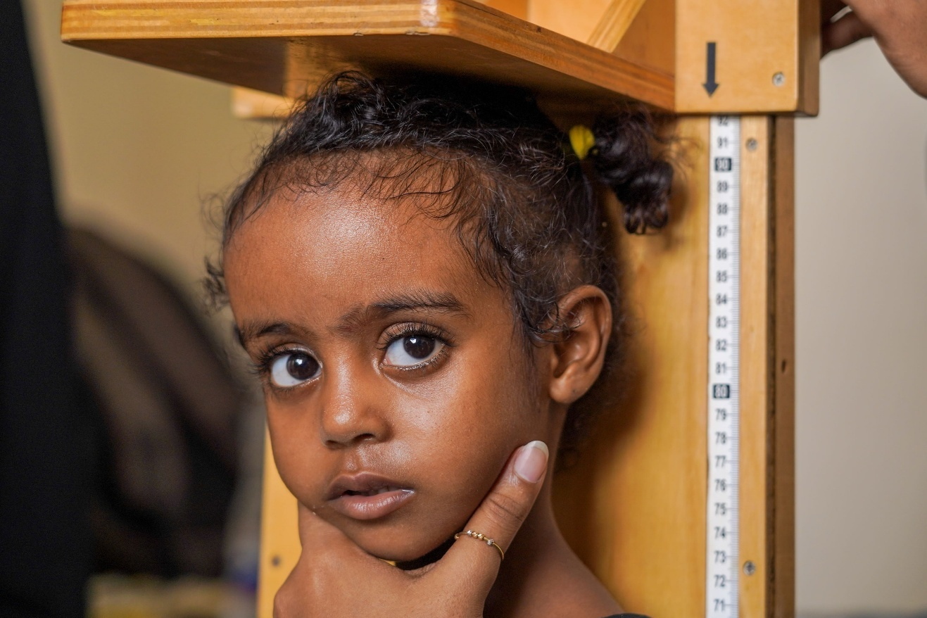
The CfN subcomponent of ESPECRP has significantly contributed to supporting vulnerable women and children at risk of malnutrition, and exceeded the project targets. Cumulatively, from the project’s inception through 31 December 2024, around 126,726 households were provided with cash assistance along with nutrition and health awareness sessions, achieving 119 percent of the overall target in 43 target subdistricts across 19 governorates. Of these households, 8,146 (87.6 percent of the target) are beneficiaries from the Social Welfare Fund (SWF). The assistance has reached 136,798 women (122.6 percent of the target) and 200,209 children (130.9 percent of the target), with girls comprising 48.5 percent of the children reached. Among the women beneficiaries, 5,095 are internally displaced persons (IDPs), and 9,810 are women with children who have disabilities.

The project trained and employed 4,535 (112.2 percent of the total target) young women as short-term Community Health Educators (CHEs) to deliver the nutrition awareness sessions and refer malnutrition cases to health facilities for treatment, generating approximately 749,663 workdays. The CHEs delivered around 667,983 home visits and 40,307 awareness sessions covering nutrition and other health-related issues, including COVID-19, reproductive health, breastfeeding, personal hygiene, malnutrition, and major water-borne diseases.

The CHEs screened children aged 6 - 59 months and pregnant and lactating women, using Mid-Upper Arm Circumference (MUAC) tapes and simple nutritional techniques, and subsequently coordinated with designated health centers to verify eligibility for additional assistance. Accordingly, 28,670 (18,520 children and 10,150 women) were identified as malnutrition cases and referred to health facilities to receive treatment. Of these cases, 18,159 cases have recovered (11,427 children and 6,732 women).

Table 7: CfN Subcomponent Progress Status cumulatively until 31 December 2024

Governorate | District | Women Educators |  | Women received CT | Children
Governorate | District | No. | Workdays | Women received CT | Boys | Girls | Total
PF
Hadhramout | Broom Mayfa'a | 100 | 17336 | 2,709 | 2,083 | 1,939 | 4,022
Hodeidah | AL-Hujailah | 69 | 14036 | 2,030 | 1,532 | 1,421 | 2,953
Raymah | Belad Atta'am | 191 | 33682 | 5,837 | 4652 | 4520 | 9,172
Lahj | Tuban | 401 | 76142 | 21,568 | 14,993 | 14,283 | 29,276
Dhamar | Jabal Asharq | 326 | 59378 | 12,154 | 9,180 | 9,110 | 18,290
Sub-total |  | 1,087 | 200,574 | 44,298 | 32,440 | 31,273 | 63,713
AF
AL-Mahwit | Bani Sa'd | 367 | 67,432 | 11,662 | 9,880 | 9,359 | 19,239
Dhamar | Al-Manar | 303 | 67,920 | 9,522 | 7,491 | 6,969 | 14,460
Hadhramaut | Ghayl Bawazir | 122 | 24,447 | 3,066 | 2,206 | 1,962 | 4,168
Al Bayda | Sabah | 102 | 20,742 | 2,811 | 2,103 | 2,056 | 4,159
Raymah | Mazhar | 89 | 17,402 | 2,311 | 1,775 | 1,685 | 3,460
Taiz | Al Misrakh | 126 | 29,553 | 3,340 | 2,374 | 2,267 | 4,641
Ibb | Far' Al Odayn | 101 | 16,297 | 2,403 | 1,904 | 1,752 | 3,656
Hajja | Ku'aydinah | 79 | 16,353 | 1,977 | 1,662 | 1,546 | 3,208
Shabwah | Bayhan | 97 | 18,495 | 2,396 | 1,616 | 1,534 | 3,150
Al Hudaydah | Al Zuhrah | 142 | 33,728 | 5,072 | 4,118 | 3,783 | 7,901
Al Jawf | Kharb Almarashi | 77 | 12,598 | 1,527 | 1,277 | 1,231 | 2,508
Marib | Ma'rib Alwadi | 118 | 17,301 | 2,350 | 1,832 | 1,719 | 3,551
Amran | Jabal Iyal Yazid | 111 | 23,143 | 3,418 | 2,525 | 2,258 | 4,783
Lahj | Tur AlBaha | 174 | 35,180 | 4,642 | 2,997 | 2,916 | 5,913
Abyan | Khanfar | 177 | 34,965 | 4,299 | 3,114 | 2,854 | 5,968
Sana'a | Hamdan | 269 | 12,736 | 7,921 | 5,492 | 5,029 | 10,521
Sub-total |  | 2,454 | 448,292 | 68,717 | 52,366 | 48,920 | 101,286
AF2
Hadhramaut | Ash Shihr | 60 | 7,707 | 1,422 | 936 | 837 | 1,773
Hajja | Al Maghrabah | 125 | 13,530 | 3,495 | 3,152 | 2,890 | 6,042
Taiz | Al Mawasit | 181 | 24,832 | 3,863 | 2,562 | 2,449 | 5,011
Ibb | Hazm Al Udayn | 58 | 8,191 | 1,017 | 891 | 868 | 1,759
Amran | Kharif | 67 | 8,912 | 1,691 | 1,271 | 1,095 | 2,366
Shabwah | Maif'ah | 61 | 3,494 | 1,211 | 923 | 790 | 1,713
Al Hudaydah | Bajil | 163 | 12,088 | 4,535 | 3,606 | 3,314 | 6,920
Raymah | Al Jafariyah | 34 | 3,910 | 563 | 413 | 416 | 829
Al-Jawf | Bart Al Anan | 52 | 1,783 | 1,441 | 1,126 | 1,007 | 2,133
Ma'areb | Jabal Murad | 25 | 2,824 | 460 | 327 | 328 | 655
Dhamar | Dawran Aness | 73 | 5,636 | 1,945 | 1,510 | 1,519 | 3,029
Baidhaa | Al Malagim | 17 | 1,245 | 477 | 326 | 325 | 651
Lahj | Al Had | 78 | 6,645 | 1,663 | 1,251 | 1,078 | 2,329
TOTAL |  | 994 | 100,797 | 23,783 | 18,294 | 16,916 | 35,210
Grand TOTAL |  | 4,535 | 749,663 | 136,798 | 151,289 | 99,654 | 149,475

In response to severe floods that intensified in July and August, affecting many supported households in some target areas, the CfN subcomponent implemented a shock-responsive adaptation by providing an additional month of cash assistance to households in the hardest-hit areas. This initiative supported 10,649 women beneficiaries across four flood-affected districts: Al-Zuhra, Ka’ydina, Kharab Al-Marashee, and Mazhar, located in the governorates of Hodeida, Hajjah, Al Jawf, and Raymah. This adaptive measure demonstrates the CfN component’s flexibility and commitment to addressing emerging vulnerabilities and enhancing resilience in crisis-affected communities.

The CfN subcomponent faced a few challenges during the reporting period, including the limited number of qualified young educators and a lack of health facilities in some of the target subdistricts. These challenges arose from the geobundling geographic targeting approach, which prioritized generic malnutrition indicators without fully accounting for specific operational requirements of the CfN subcomponent. To mitigate this, qualified women from neighboring subdistricts were engaged, and additional transportation allowances were provided to enable target women to access health facilities in other areas.

Furthermore, the absence of national IDs continued to complicate beneficiary verification and service delivery, which SFD paid efforts to solve by assisting these women in obtaining IDs but the limited capacity of issuing agencies has hindered progress. Reduced funding for many health centers and Outpatient Therapeutic Feeding Program (OTP) centers has constrained the ability to meet the needs of referred malnourished cases. Addressing the essential needs of health centers in targeted areas would greatly enhance the impact of the CfN subcomponent and foster the project’s effectiveness in tackling malnutrition, a persistent challenge for vulnerable populations in Yemen.

Subcomponent 2.2 Cash for Work (CfW)
Table 8: CfW Intermediary Indicators status since inception until 31 December 2024
Subcomponent 2.2 CfW Intermediary indicator | PF Targets | % PF Result | AF Targets | % AF Result | AF2 Target | % AF2 Result | Total Targets | Total Result | % Result
# direct beneficiaries of wage employment | 21,500 | 98% | 38,000 | 58% | 18,200 | 0% | 77,700 | 43,009 | 55.4%
# beneficiaries (women) (30%) | 6,450 | 102% | 11,400 | 65% | 5,460 | 0% | 23,310 | 13,985 | 60.0%
# indirect beneficiaries of wage employment | 129,000 | 98% | 165,312 | 31% | 78,000 | 5% | 372,312 | 182,407 | 49.0%
# people with increased access to basic services | 138,500 | 214% | 220,000 | 40% | 94,250 | 0% | 452,750 | 384,790 | 85.0%
Cubic meters of water schemes constructed/rehabilitated (m3) | 20,746 | 37% | 18,300 | 36% | 7,020 | 0% | 46,066 | 14,188 | 30.8%
Area of agriculture land rehabilitated (Hectare) | 879 | 49% | 1,000 | 161% | 598 | 0% | 2,477 | 2,040 | 82.4%
Length of roads improved (km) | 45 | 195% | 92 | 66% | 72 | 0% | 209 | 149 | 71.3%
Workers setting up the foundation of water tank tower as a part of the geo-bundling interventions in Al-Majhafa, Lahj. | Photo Credit: @UNDP Yemen / 2024
Under the Cash for work (CfW) subcomponent, the project contributed to support vulnerable people in conflict-affected communities to cope up with the crisis of food insecurity and mitigate the negative impact of climate change through creating temporary job opportunities as well as building essential community assets at the same time.

From the start of the project through the end of December 2024, a total of 243 CfW sub-projects were identified, for an estimated cost of US$35.9 million (representing around 82 percent of the total allocation for CfW under the three funds of ESPECRP) in 113 districts across all the 22 governorates of Yemen. Out of these, 105 sub-projects (US$ 14.5 million) were completed, 105 sub-projects (US$ 16.2 million) are under implementation, and 29 sub-projects (US$ 4.3 million) are in the initial preparatory stage. As reported in the previous report, four sub-projects were cancelled under the parent fund. The CFW sub-projects have addressed a range of critical community needs, including the protection of agricultural lands, rehabilitation of irrigation canals, implementation of rainwater harvesting schemes, pavement of rural roads, establishment of home gardens, and construction of latrines.
The subcomponent activities under the PF were successfully completed. Meanwhile, the AF is approximately halfway through implementation, with expected completion by the end of 2025. As for AF2, technical and safeguard studies have been completed for approximately 40 percent of the allocated funds, with the implementation anticipated to commence in the first quarter of 2025, contingent on the timely submission and clearance of safeguard plans.

Sub-projects | Completed |  | Ongoing |  | Cancelled |  | In Preparation |  | Total Sub-projects
Intervention Type | # | US$ | # | US$ | # | US$ | # | US$ | # | US$
CfW - Agriculture | 4 | 328,038 | 9 | 1,467,399 | 0 | 0 | 0 | 0 | 13 | 1,795,437
CfW - Diversified | 63 | 9,124,636 | 72 | 11,400,531 | 2 | 362,107 | 15 | 2,333,289 | 152 | 23,220,563
CfW - Roads | 30 | 3,980,497 | 24 | 3,294,671 | 1 | 198,000 | 14 | 1,951,819 | 69 | 9,424,987
CfW - WASH | 8 | 1,020,885 | 0 | 0 | 1 | 331,000 | 0 | 0 | 9 | 1,351,885
Grand Total | 105 | 14,454,056 | 105 | 16,162,601 | 4 | 891,107 | 29 | 4,285,108 | 243 | 35,792,872
Table 9: Status of CfW Sub-projects as of 31 December 2024

To date, 43,009 direct workers (55.4 percent of the project target) benefited from short-term CfW wage employment, helping them to purchase their basic needs including food and medicine while at the same time contributing to improving livelihoods conditions and communal services. The direct workers included 32.5 percent women, 12.6 percent IDPs, and 52.7 percent youth. Around 651 Persons with Disabilities (21 percent women) were engaged in CfW thus far in activities including construction of latrines, painting, terraces rehabilitation, life skills training, and awareness sessions, among others.

Over 4,844 unskilled or semi-skilled workers received a variety of on-the-job-trainings in different works such as building, stone cutting and paving, and cement plastering, as well as to operate and maintain assets after completing the sub-project. Such skills will help them continue finding income generating opportunities later on and thus enhancing the resilience of their households and communities. The project also encouraged the beneficiary HHs to acquire productive assets (1,806 assets acquired including cows, sheep and goats, poultry, bee sticks, sewing machines, motorcycles, compressors, etc.) to improve their income. The implemented sub-projects created 907,096 workdays, and the benefits were extended indirectly to around 168,624 HH members.
The table below provides disaggregated CfW workers per governorate:
Table 10: CFW Disaggregated Workers and Workdays per Governorate as 31 December 2024

GOVERNORATE | No. of SUB-PROJECTS | NO. OF WORKERS |  |  |  | NO. OF WORKDAYS
GOVERNORATE | No. of SUB-PROJECTS | TOTAL | WOMEN | IDPS/RETURNEES | YOUTH | NO. OF WORKDAYS
Abyan | 7 | 1299 | 285 | 27 | 562 | 54,890
Aden | 4 | 625 | 168 | 173 | 368 | 14,585
Al Baidha | 10 | 1315 | 666 | 32 | 781 | 40,752
Ad-Dhale’e | 10 | 1171 | 204 | 243 | 591 | 37,113
Al-Jawf | 6 | 1241 | 231 | 70 | 637 | 49,225
Al Mahrah | 3 | 595 | 254 | 103 | 365 | 17,611
Al Mahweet | 9 | 823 | 30 | 106 | 451 | 25,991
Amran | 13 | 1728 | 91 | 17 | 926 | 55,862
Dhamar | 15 | 2435 | 1103 | 11 | 1274 | 80,566
Hadhramout | 11 | 1824 | 281 | 8 | 728 | 83,053
Hajjah | 22 | 5995 | 2179 | 1254 | 3330 | 168,967
Hodeidah | 23 | 5867 | 2772 | 99 | 3128 | 232,361
Ibb | 21 | 4528 | 2077 | 442 | 2387 | 148,446
Lahj | 9 | 1219 | 184 | 22 | 574 | 50,714
Marib | 11 | 1711 | 612 | 618 | 953 | 41,792
Raymah | 7 | 1049 | 337 | 9 | 423 | 47,728
Sa’adah | 11 | 1324 | 104 | 225 | 629 | 52,627
Sana’a | 11 | 1590 | 146 | 196 | 902 | 40,008
Sana’a Capital | 5 | 1119 | 150 | 445 | 762 | 22,369
Shabwah | 7 | 1551 | 505 | 46 | 899 | 37,495
Socotra | 4 | 363 | 57 | 0 | 150 | 12,652
Taiz | 24 | 3637 | 1549 | 1253 | 1855 | 95,732
TOTAL | 243 | 43009 | 13985 | 5399 | 22675 | 1,410,539

In addition to providing emergency income for vulnerable individuals, the project has provided access to key social services prioritized by the target communities through an effective participatory approach. Rainwater harvesting schemes with a capacity of 14,188 cubic meters (30.8 percent of the total target) were constructed, addressing critical needs for clean drinking water and other uses. Around 2,040 (82.4 percent of the total target) hectares of agricultural lands and terraces have been rehabilitated and irrigated, enhancing food production and availability. Also, 149 (71.3 percent of the target) kilometers of feeder roads were repaired through stone-pavement, improving community access to markets and services.

Additionally, the CfW interventions addressed other vital community priorities, including: creation of 1,255 home gardens to support household food security; paving of 52,949 square meters of streets to improve urban infrastructure; construction of 150 shelters for vulnerable individuals; rehabilitation of 71 drinking water wells to ensure access to clean water; protection of 287 houses from floods and encroaching sands; building of 6,670 household latrines to improve sanitation and reduce the spread of water-borne diseases. Each of these community assets have contributed to enhanced food security and climate adaptation for the target communities. The completed sub-projects have improved access to key services for around 304,464 people living in the communities (67.2 percent of the target) of whom around half are women.

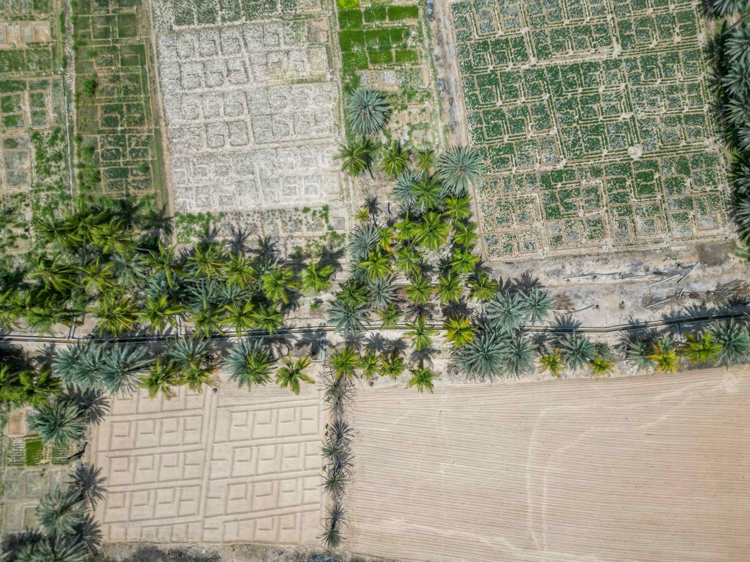

Table 11: CfW HH, Workers, and workdays per sector and category as of 31 December 2024

Intervention | # | NO. OF HH | NO. OF WORKERS |  |  |  | NO. OF WORKDAYS
Intervention | # | NO. OF HH | TOTAL | Women | IDP | YOUTH | TOTAL | Women | IDP | YOUTH
Agriculture | 13 | 2,208 | 2,715 | 28% | 1% | 52% | 95,940 | 20% | 1% | 49%
Diversified | 152 | 20,594 | 27,942 | 37% | 13% | 52% | 927,681 | 30% | 12% | 49%
Roads | 69 | 7,645 | 8,544 | 17% | 17% | 57% | 266,225 | 12% | 14% | 56%
WASH | 9 | 2,567 | 3,808 | 37% | 10% | 52% | 120,693 | 27% | 10% | 49%
TOTAL | 243 | 33,014 | 43,009 | 32.5% | 12.6% | 52.7% | 1,410,539 | 26% | 11% | 50%
A key challenge facing the CfW subcomponent has been the delays in clearances of the Environmental and Social Action Plans (ESAPs), resulting in implementation delays. While there was notable understanding from the WB’s team about the issue and improvement in the clearance turnaround, there is still a need to expedite the implementation of the recommended simplification of the requirements and expedition of the process. The discussions are ongoing with the WB with a view to addressing the causes of delays and implementing the recommended simplification within the first quarter of 2025.
The previously reported delays involved in the operationalization of geobundling have been sorted out as all of the subdistricts needs assessment reports were finalized. However, some delays in obtaining permits from the DFA were faced in some of the northern areas, which the IPs continued to address through negotiations and lobbying.

Subcomponent 2.3 Community Assets (CA)
Table 12: CA Intermediary Indicators status since inception as of 31 December 2024

Subcomponent 2.3 CA Intermediary indicator | PF Targets | % PF Result | AF Target | % AF Result | AF2 Target | % AF2 Result | Total Target | Total Result | % Result
# direct beneficiaries of wage employment | 16,940 | 72% | 25,173 | 24% | 9,880 | 0% | 51,993 | 18,926 | 36.4%
# women beneficiaries (3%) | 508 | 96% | 1,259 | 7% | 400 | 0% | 2,167 | 655 | 30.2%
# indirect beneficiaries of wage employment | 101,640 | 72% | 151,038 | 24% | 59,280 | 0% | 311,958 | 113,556 | 36.4%
# people with increased access to basic services | 255,000 | 167% | 291,330 | 42% | 123,800 | 0% | 670,130 | 573,089 | 85.5%
Water schemes constructed (m3) | 57,000 | 109% | 63,042 | 10% | 27,360 | 0% | 147,402 | 72,106 | 48.9%
hectare of agri land rehabilitated | 1,600 | 158% | 2,522 | 14% | 890 | 0% | 5,012 | 2,922 | 58.3%
Length of roads improved (km) | 38 | 127% | 66 | 13% | 59 | 0% | 163 | 57 | 35.1%
Since the project's inception up until the end of December 2024, PWP approved 367 sub-projects (150 under PF, 174 AF, 43 AF2) at an estimated cost of US$ 35.7 million. Of these sub-projects, 166 sub-projects (150 under PF and 16 under AF) were completed at the cost of US$ 13.5 million. Selected based on the priorities of target communities in 200 districts across all 22 governorates of Yemen, these sub-projects have played a crucial role in enhancing essential community services. Key interventions include the construction of communal rainwater harvesting reservoirs, rehabilitation of water supply and sanitation networks, stone-paving of rural roads, and protection of agricultural lands, contributing to improved living conditions and resilience in conflict-affected areas.
The PF activities have been fully completed. Whereas, the AF has 79 sub-projects under implementation (estimated cost US$ 8.8 million), 36 sub-projects completed (US$ 2.9 million) and 102 sub-projects (US$ 11.9 million) under preparation. Under AF2, PWP has completed the technical studies for 43 sub-projects (costing around US$ 5.3 million) in 26 subdistricts. PWP will submit the safeguard plans for these sub-projects in January 2025 and prepare for the implementation from February 2025 onwards.
Out of the total approved sub-projects, the number of the community contracting (CC) sub-projects is 73 (23 under the PF, 36 under the AF and 14 under AF2) with an estimated amount of US$ 7.8 million. Thus far, 23 community contracting sub-projects were completed, 11 sub-projects are under implementation, and the remaining ones are under preparation of technical studies. The CC modality has revealed an additional impact to the communities.
A number of the trained community committee members have advanced to skilled contractors, while women were empowered to take on active roles, with two women successfully bidding for projects such as constructing water harvesting tanks in Taiz and rehabilitating a canal in Dhamar. Community committees, equipped with contracting and administrative skills, now independently manage similar activities and have mobilized significant resources.
a rugged, steep road was paved through PWP’s community contracting in Al-Sarrah, Al-Odein, Ibb. | Photo Credit: @UNDP Yemen / 2023

Table 13: Status of Sub-projects under Subcomponent 2.2 (PWP) as of 31 December 2024

Sub-projects | Approved |  | Under implementation |  | Completed
Sector of Intervention | No. | US$ | No. | US$ | No. | US$
Agri Land Protection & irrigation | 133 | 12,847,300 | 25 | 2,538,500 | 75 | 6,117,983
Rainwater Harvesting | 81 | 7,573,973 | 16 | 1,810,326 | 29 | 2,399,425
Stone Paving Rural Roads | 80 | 9,056,074 | 26 | 3,405,797 | 30 | 2,387,491
Water Supply Schemes | 66 | 5,817,471 | 11 | 982,631 | 46 | 3,734,910
Sanitation | 7 | 386,888 | 1 | 32,144 | 6 | 354,744
Total | 367 | 35,681,706 | 79 | 8,769,398 | 186 | 14,994,554

The subcomponent has achieved noticeable impact since project inception, particularly in terms of improving the access to services for communities affected by food insecurity as well as enhancing resilience of vulnerable people.
The project has provided short-term wage employment to 18,926 direct workers (36.4 percent of the total target combining PF, AF & AF2), of whom 655 were women (30.2 percent of the target) and 2,863 were IDPs (15.1 percent of the total direct beneficiaries). The project benefited 113,556 indirect beneficiaries as household members and generated 381,510 workdays.
Table 14: CA Disaggregated Workers and Workdays per Governorate

GOVERNORATE | No. of SUB-PROJECTS | NO. OF WORKERS |  |  |  | NO. OF WORKDAYS
GOVERNORATE | No. of SUB-PROJECTS | TOTAL | WOMEN | IDPS/RETURNEES | YOUTH | NO. OF WORKDAYS
Abyan | 8 | 477 | 0 | 36 | 441 | 11,496
Aden | 9 | 519 | 6 | 210 | 303 | 14,769
Al Baidha | 7 | 534 | 20 | 112 | 402 | 11,404
Ad-Dhale’e | 5 | 467 | 14 | 29 | 424 | 9,094
Al-Jawf | 8 | 799 | 6 | 208 | 585 | 12,517
Al Mahrah | 8 | 462 | 8 | 25 | 429 | 12,123
Al Mahweet | 7 | 461 | 10 | 28 | 423 | 9,801
Amran | 14 | 894 | 5 | 213 | 676 | 18,510
Dhamar | 16 | 1316 | 53 | 62 | 1201 | 26,084
Hadhramout | 7 | 407 | 11 | 59 | 337 | 6,931
Hajjah | 20 | 1457 | 24 | 203 | 1230 | 33,684
Hodeidah | 17 | 1237 | 13 | 11 | 1213 | 23,152
Ibb | 20 | 1425 | 86 | 104 | 1235 | 28,843
Lahj | 11 | 435 | 8 | 6 | 421 | 7,568
Marib | 17 | 1139 | 15 | 467 | 657 | 28,762
Raymah | 8 | 509 | 3 | 10 | 496 | 8,644
Sa’adah | 16 | 1422 | 40 | 492 | 890 | 25,585
Sana’a | 7 | 486 | 48 | 109 | 329 | 12,594
Sana’a Capital | 15 | 1394 | 72 | 129 | 1193 | 29,963
Shabwah | 14 | 1069 | 89 | 85 | 895 | 13,563
Socotra | 8 | 354 | 15 | 6 | 333 | 6,070
Taiz | 23 | 1663 | 109 | 259 | 1295 | 30,353
TOTAL | 265 | 18,926 | 655 | 2,863 | 15,408 | 381,510
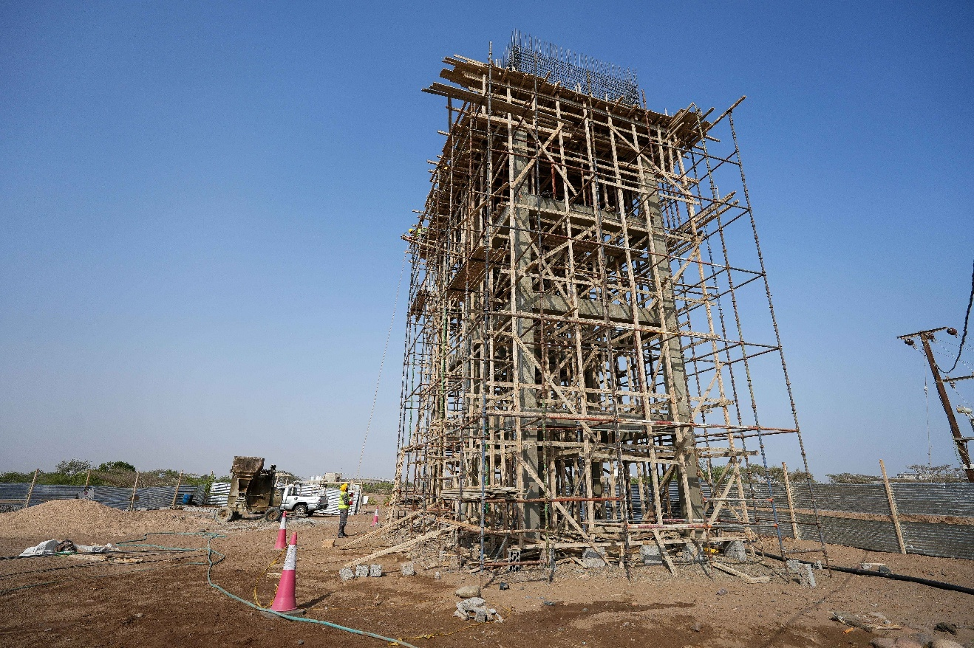
The 186 completed sub-projects directly contributed to enhancing community resilience and access to essential services as well as contributing to climate adaptation. These efforts included construction of rainwater harvesting reservoirs with a combined capacity of 72,106 cubic meters (48.9 percent of the total target), ensuring safer and more reliable access to clean water for vulnerable communities. Furthermore, around 74,482 meters of the water-supply network and 1,427 of sanitation networks were repaired, and four public latrines were constructed. The water and sanitation interventions ensured climate-related co-benefits through utilization of rainwater harvesting for agriculture, strengthening of sustainable water management practices, and reducing the spread of climate-induced water-borne diseases.
The subcomponent has also contributed to food production and flood mitigation through climate-resilient interventions protecting and rehabilitating 2,922 hectares of agricultural lands (58.3 percent of the target). Additionally, the improvement of 57 kilometers of rural roads (35.1 percent of the target) reduced transportation challenges and associated costs for remote communities, fostering greater connectivity and economic opportunities. The retaining walls built along the road interventions helped in mitigating potential landslide. Generally, the planting of trees in most sub-project sites along with awareness raising on climate change have enhanced the climate-related co-benefits of the project. Collectively, the completed sub-projects improved access to key services for 573,089 people (representing 85.5 percent of the total target).
Table 15: Total Job Opportunities under CA as of 31 December 2024

Sector | Workdays generated |  |  | Direct Beneficiaries of wages
Sector | Total | % Host Community | % IDP's | Total | % Host Community | % IDP's
Water harvesting tanks | 47,453 | 82% | 18% | 2,332 | 84% | 16%
Land Protection & Irrigation | 115,663 | 81% | 19% | 5,764 | 77% | 23%
Rural roads pavement | 149,655 | 88% | 12% | 7,448 | 91% | 9%
Sanitation & Water supply | 68,739 | 86% | 14% | 3,382 | 84% | 16%
Total | 381,510 | 85% | 15% | 18,926 | 85% | 15%
A key challenge for this subcomponent was the difficulty in community engagement and data collection in the North due to restrictions imposed by the DFA. To address this, PWP effectively coordinated with community committees and Village Cooperative Councils (VCCs), focusing on collecting the most critical data necessary for technical and safeguard planning and monitoring. Another ongoing challenge has been the lengthy safeguard preparation and clearance process. While some improvements have been made, further streamlining and faster turnaround times are essential to enhance efficiency and project implementation.

Subcomponent 2.4: Economic Opportunities and Food Market Resilience
Table 16: MSMEs Intermediary Indicators as of 31 December 2024

Subcomponent 2.4 MSMEs Intermediary indicator | PF Target | % PF Result | AF Target | % AF Result | AF2 Target | % AF2 Result | Total Target | Total Result | % Result
# MFIs to access YLG guarantee portfolio guarantee scheme | 3 | 100% | 2 | 100% | 1 | 100% | 6 | 6 | 100.0%
Number of SME loans guaranteed by the new capitalization to the YLG | 3,024 | 105% | - | - | 730 | 189% | 3,754 | 4560 | 121.5%
Number of Village Saving and Loans Associations | 30 | 150% | 500 | 98% | 185 | 35% | 715 | 597 | 83.5%
SMEs receiving TA and grants that produce and facilitate food distribution | 1,630 | 103% | 3,200 | 49% | 1,425 | 0% | 6,255 | 3,233 | 51.7%
Business associations supported in the target sectors directly through grants and TA | 20 | 100% | 30 | 20% | - | 0% | 50 | 55 | 110.0%
Number of new seasonal and permanent wage employment supported | 8,320 | 175% | 9,600 | 122% | 3,675 | 0% | 21,595 | 26,248 | 121.5%

Subcomponent 2.4a Increased Access to finance for MSMEs

Yemen Loan Guarantee program (YLG):
By implementing the Portfolio Guarantee Model (PGM), ESPECRP through the Yemen Loan Guarantee (YLG) has enhanced credit risk mitigation for financial institutions and Micro-Finance Institutions (MFIs), enabling increased and easier lending to a larger number of MSMEs in the food production sector. This approach fostered business growth, job creation, and local economic expansion, contributing to poverty reduction, improved living standards, and sustainable development in Yemen. The project signed contracts with the six selected MFIs (100 percent of the target) to access the PGM of YLG. Through them, the project provided guaranteed loans to 4,560 MSMEs (121.5 percent of the total target), which in turn created or sustained around 7,283 job opportunities, contributing to the stabilization of sustainable livelihoods and the local economy. The value of guaranteed loans totaled US$13 million, highlighting the program's positive impact on improving SMEs' ability to secure financing.

Table 17: Number of guarantees issued and sum of guaranteed amount as of 31 December 2024

Key indicator | Alamal MF | Azal MF | Alitihad MF | Alkuraimi MF | Althadhamon | Nama MF | Total
# of Guarantees | 89 | 1,721 | 342 | 2,014 | 199 | 195 | 4,560
Around 46.5 percent of the supported MSMEs were in rural areas, and around 17 percent of them were in the South. Furthermore, 52.3 percent of the MSMEs were youth-led and 14.7 percent were women-led. The supported MSMEs included a variety of productive and economic sectors, such as the agricultural sector (29.6 percent) covering crop production and beekeeping; commercial (47.9 percent) retail and wholesale businesses; livestock (13.8 percent) including cattle ranching, poultry farming and aquaculture; service (4.4 percent) such as hairdressing and food logistics; and industry (3.5 percent) with activities like bakeries, sewing, and sesame oil production.
The ongoing challenge is the requirement to increase the number of women-led MSMEs. The challenge has been partly mitigated through applying the WB-agreed measure of targeting women-led MSMEs in all income-generating activities rather than the food security sector only. In addition, YLG will increase coordination with partners to seek new loans products and incentivize MFIs by increasing the risk coverage of women-led MSMEs as well as conducting workshops and capacity building activities.
IT Support to MFIs:
This activity, completed earlier under the PF, provided $38,000 grants to each of the two target MFIs (Azal and Hadhramout) to enhance their IT infrastructures and digitalization strategies. The establishment of data centers has streamlined IT resource management, improved data safety and security, and optimized application and system planning. These centers now offer reliable performance, cost efficiency, and the capability to handle big data and artificial intelligence, ensuring 24/7 data accessibility and robust technical support for improved operational efficiency.
Village Saving and Loan Associations (VSLAs) :
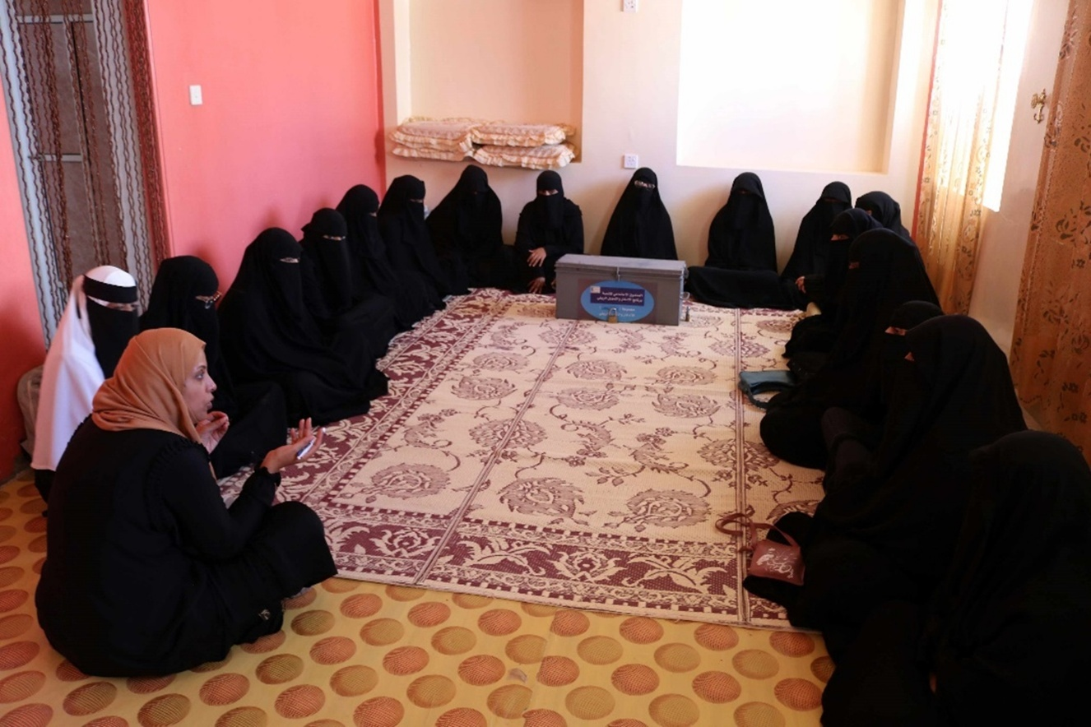
VSLAs have proven to be a transformative tool for poverty alleviation, financial inclusion, and economic empowerment, particularly in underserved rural areas. By providing accessible and sustainable financial services, VSLAs promote entrepreneurship, create job opportunities, and enhance resilience among the most vulnerable communities. Cumulatively by the end of December 2024, the project formed 597 VSLAs (83.5 percent of the total target) of which 50 percent are women VSLAs.

Through community mobilization and capacity-building initiatives, the project has equipped 14,719 VSLA members (of whom 7,333 are women) with VSLA-related materials, including cash boxes and stationery, as well as with training in savings, lending, financial literacy and entrepreneurship. To enhance the financial skills and ensure effective record-keeping of the VSLAs, 6,780 (53 percent women) of the VSLA members received a five-day training on financial accounting.
In addition, the project provided 2,055 (1,263 women members, 61 percent) with vocational skills training. All these efforts have strengthened members’ ability to manage their finances, operate SMEs effectively, and improve their livelihoods. Cumulatively, 833 loans (of which 447 are by women-owned MSMEs, 54 percent) amounting to YER 125.61 million (US$ 235K equivalent) have been issued, supporting diverse economic activities and creating or sustaining 1,666 job opportunities.
Table 18: Loans Disbursed by VSLAs

Business Type/ Sector | N. of loans disbursed (Accumulative) |  |  | %
Business Type/ Sector | Men | Women | Total | %
Beekeeping, Livestock, and Agricultural | 175 | 162 | 337 | 40
Commercial | 110 | 138 | 248 | 30
Handcraft/Industry | 12 | 121 | 133 | 16
Service | 89 | 26 | 115 | 14
Total | 386 | 447 | 833 | 100%

These achievements highlight the VSLAs’ vital role in fostering financial independence, improving living standards, and driving sustainable economic growth in Yemen. Moreover, VSLAs foster the essential habit of saving, empowering members to build financial security and resilience, and specifically empowering women by giving them access to finance, decision-making opportunities, and a platform to voice their needs and concerns.
The impact of VSLAs is constrained by two key challenges: limited savings amounts, which restrict members to micro-level income-generating activities, and insufficient project funding, which allows vocational training for only a portion of the members. To overcome these limitations and maximize the VSLAs' potential, additional funding is needed to provide access to revolving interest-free loans and to extend vocational training to all VSLA members.

Sub-comp 2.4b Direct support to MSMEs and Business Associations in Critical Sectors:
one of SMEPS’ consultants explains to some women livestock breeders proper ways to feed their livestock. | Photo Credit: @UNDP Yemen / 2022

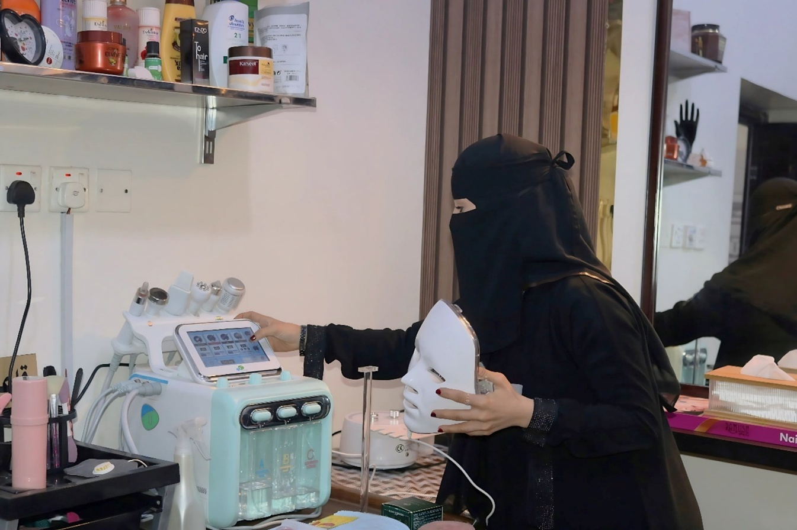
This subcomponent of ESPECRP, implemented by SMEPS, has significantly contributed to household and community food security by supporting MSMEs, micro-producers, SMEs, and cooperatives to sustain vital production in a fragile context. Overall, the PF activities were completed over a year ago while the AF is almost halfway and the AF2 has completed the preparatory works to commence implementation of activities from the first quarter of 2025.

As of December 31, 2024, ESPECRP has supported 2,563 MSMEs (24.8 percent women-led) across 13 governorates with grants and technical assistance, achieving 69.3 percent of the target under the combined PF, AF, and AF2 grants. The supported MSMEs included 954 farmers, 469 livestock breeders and 250 fishermen, 663 supply chain enablers, and 164 entrepreneurs, fostering business linkages and strengthening value chains in the food market. The support has enhanced business resilience and livelihoods, creating 17,565 jobs (14 percent for women).
The project also bolstered 30 Business Cooperatives (BCs) and 33 Business Associations (BAs) through asset transfers and capacity building, improving their operations and risk management while promoting strategic growth. Support for the Yemen Private Sector Cluster (YPSC) helped unify private sector voices amidst institutional fragmentation, with capacity assessments, training, and studies on e-money and private sector roles in recovery, further enhancing sectoral development. Additionally, climate-smart practices, such as solar systems, drip irrigation, and sustainable agriculture, have reduced CO2 emissions, conserved water, and expanded food production, underscoring the subcomponent’s contribution to climate adaptation and sustainability.
The primary challenge hindering progress was the prolonged delay by SCMCHA in granting permits for SMEPS to implement activities in the northern governorates. This bureaucratic hurdle significantly disrupted the delivery timeline and delayed the planned interventions. However, the issue was resolved in September 2024 through persistent negotiations and active coordination with the authorities. Further delay was caused by the shortage of inputs (i.e. drip irrigation systems, seeds, fertilizers, pesticides) and rising prices, attributed to complications in the Red Sea and the banking sector.

Component 2 Project Management, Monitoring, Evaluation and Capacity Building of National Institutions

Project Management Unit (PMU): There is no change in this subject since the last report as the project team is fully staffed and the UNDP Country Office continues to extend the support required to the project.
ESPECRP Procurement Plan (the procurement plan was updated in this link): The procurement plan has been revised to reflect the new developments in the context and the delays caused by late permits in the North, lengthy E&S clearance processes, and SDR exchange rate depreciation. However, the progress in implementing the procurement plan has been relatively stronger during the reporting period compared to the previous period largely due to a good number of subprojects receiving safeguards clearance and commencing implementation. Problematic procurement issues included the contract with the International Food Policy Research Institute (IFPRI) for the impact evaluation of geobundling which had to be suspended due to security risks in the North; and the Third-Party Monitoring Agency (TPMA) procurement process that had to be renewed as the contract was expiring and the quality of reporting was substandard. UNDP and the WB are exploring options to achieve objectives up to the required quality and compliance standards and without exposing staff to risks.
During the reporting period, 15 procurement-related complaints were recorded—11 by SFD and 4 by PWP. The primary issues included exclusion from bidding, inadequate or untimely communication, contract termination without notice, and disputes during implementation. All complaints were addressed by the IPs, with only one pending related to a bidding inquiry.
The implementation of the procurement plan faced several challenges, including security escalations impacting supply chains and increasing costs due to difficult border and transport access, financial disruptions stemming from the banking conflict between the South and North affecting liquidity and prices, weak infrastructure and restricted access between governorates raising transportation expenses, and a shortage of competitive suppliers, particularly for specialized consultancy services. UNDP, alongside other UN agencies and IPs, continues to monitor these challenges and explore solutions to ensure the uninterrupted delivery of assistance. To strengthen procurement risk management, there is a need to enhance the capacity of IPs. The WB has recently initiated a capacity assessment exercise with plans to address key gaps in the next reporting period.

Geobundling Approach (GB): The implementation of geobundling (GB) for AF has progressed well during the reporting period, while AF2 has experienced delays due to late permits from SCMCHA in the North and the time required to conduct needs assessments and gather other data to inform impact evaluation design requirements.
SFD, PWP, and SMEPS in Aden meet to discuss the implementation plan for Al-Majhaf, Lahj, geo-bundling | Photo Credit: @UNDP Yemen / 2024

ESPECRP has targeted 128 subdistricts for the GB approach based on high levels of malnutrition and food insecurity. Of these, 67 subdistricts were targeted under AF with the implementation of sub-projects progressing across all of them, and 40 subdistricts under AF2 where the implementation is anticipated to commence in the second quarter of 2025. In addition, 11 subdistricts have been deferred to AF3 as control areas randomized for the GB impact evaluation, and the remaining 10 subdistricts had to be held on until their ground situation improves and more funding is made available.
Some key process indicators achieved thus far along the operationalization of GB include:
- 1566 consultants, including 763 women, trained on SFD’s Tamkeen community mobilization approach to train and guide the target communities in organizing themselves into structures and preparing their needs plans.
- 1318 Village Cooperation Councils (VCCs), comprising 6939 men and 6796 women members, established, trained in participatory needs assessment and engaged in preparing their village needs plans.
- 119 Sub-District Development Committees (SDDCs), including 1303 women and 1419 men, elected by the VCCs and trained in needs analysis and resilience planning in collaboration with local authorities.
- 116 Sub-districts Needs Plans (SDNPs) prepared by the SDDCs and co-endorsed by relevant local authorities.
- 94 Sub-District geobundling Plans approved collectively by the IPs based on the community priorities and the project’s objectives.
The GB governance structure, comprising the central working group and the governorate bundling teams, continued to meet regularly to oversee the progress made. Based on feedback from the field and recommendations from previous workshops, UNDP organized a workshop in Aden (December 2024) for the field officers in the South to enhance the knowledge about GB at the field level and discuss lessons learned from the implementation of the approach thus far. The workshop concluded that the overall progress is good with increasing improvement in the understanding of the GB process and the coordination among the IPs.
However, more efforts are still needed to ensure clearer complementarity among the various interventions to achieve the GB impact more effectively. The participants indicated that the delay in approving safeguard plans of some interventions disabled the possibility of synchronizing the implementation and hence missing the opportunity of mutual reinforcement among the interventions. Long delays have affected the communities’ trust about the GB, causing resentment of the communities waiting for their interventions to begin and challenges for the ongoing interventions in the other communities within the same subdistrict. Furthermore, the delay in starting the implementation has caused issues including changes in household’s registry, community priorities, or relations with authorities.
Key recommendations of the workshop included the need for: stronger engagement of local authorities to maintain their support for the GB approach throughout the implementation period; additional capacity building for the SDDCs and local authorities in social cohesion and community monitoring; more effective communication of the GB messages to stakeholders; capacity building of the field teams on conflict sensitivity; further detailed operations manual along with specific monitoring indicators; allocation and capacity for GB visibility and documentation.
Additionally, the participants stressed the importance of more simplified safeguard clearance processes and quicker turnaround of approvals from the head offices to enable more effective coordination in the field. More frequent (at least bi-annual) workshops on GB were strongly recommended for reflection and exchange of experiences among the different teams from different branches of the IPs.
Institutional Capacity Building (ICB): The implementation of ICB has progressed well during the reporting period, with several ICB activities launched, including financial training for all IPs, value for money methodology and Procurement Manuals updated for SFD, integrated MIS for PWP, and Impact Evaluation training, as well as Training of Trainers (TOT) on occupational health and safety (OHS) and Gender Based Violence (GBV) for all IPs. This progress is added to the already achieved capacity activities through the project or directly by the WB, as reflected in the updated status of the ICB action plan available at this link.

Monitoring and Evaluation

UNDP Field Visits
UNDP team met with health educators and mothers in Sawakh, Hajjah, who benefited from the cash-for-nutrition programme and its services. | Photo Credit: @UNDP Yemen / 2024
Cumulatively since inception till December 2024, UNDP conducted field visits to 77 sub-project sites across 31 districts in eight governorates, focusing on community engagement, compliance, and implementation quality. Particular attention was given to monitoring 24 geobundled sub-projects in Sa’ada, Amran, Hadramout, and Ibb. Using beneficiary interviews, focus group discussions, and direct observations, the visits revealed significant progress in addressing local priorities through programs such as CfN, CfW, and VSLAs. These initiatives collectively enhanced food security, community assets, and resilience, with beneficiaries often experiencing amplified benefits from participation in multiple programs.
Key challenges included insufficient coordination among partners, delays in environmental plan approvals, and logistical obstacles. While progress has been made in improving coordination and clarifying the geobundling approach, sustained community engagement and better alignment among stakeholders are critical for maximizing long-term impacts. Recommendations from field visits and workshops are fostering stronger partnerships and more effective implementation, laying the groundwork for sustainable and inclusive outcomes. The field visits report can be found in this link.
Third Party Monitoring (TPM)
Since the inception of the ESPECRP project, significant achievements have been documented through data gathered by the TPMA. Cumulatively, 229 sub-projects have been visited and verified, encompassing all project subcomponents: Cash for Nutrition (CfN: 22 sub-projects), Cash for Work (CfW: 87 sub-projects), Small Community Infrastructure (83 sub-projects), and Small and Medium Enterprises (SMEs: 37 sub-projects). The monitoring visits were geographically balanced, with 53 percent conducted in northern governorates and 47 percent in southern governorates.
Over this period, the TPMA interviewed 5,783 direct beneficiaries, 71 percent of whom were men and 27 percent women. Additionally, 703 key informants were engaged, predominantly community committee members (89 percent men and 11 percent women). The agency also identified 960 indirect beneficiaries, with a demographic split of 60 percent men and 40 percent women. Furthermore, 2,046 community members participated in 340 focus group discussions (FGDs), ensuring diverse representation with 60 percent men and 40 percent women participants. These engagements provided valuable insights into the effectiveness of project interventions and their alignment with community needs.
In 2024, the TPMA, represented by Apex Consultancy Firm, assessed and verified 71 new sub-projects across governorates in both the North and South, including Hajjah, Dhamar, Ibb, Aden, Taizz, Lahj, and others. During this reporting period, 1,535 interviews were conducted, involving 1,046men and 489 women. These figures demonstrate a strong commitment to community engagement and inclusivity throughout the project lifecycle, emphasizing the effective outreach and measurable impact of the interventions. A summary of key findings for each subcomponent is as follows, and further details can be found in the TPMA reports.
Cash for Nutrition (CfN):
The Cash for Nutrition (CfN) initiative demonstrated significant progress in combating malnutrition during the reporting period, as evidenced by interviews with 118 beneficiary mothers and 54 community health educators. Training sessions on nutrition, hygiene, and breastfeeding improved participants' knowledge, with 92 percent of mothers reporting enhanced nutritional well-being for themselves and their children. Community health educators also noted improved capabilities, enabling them to guide beneficiary mothers effectively. Cash transfers were disbursed during training sessions, although delays of up to four months affected 40 percent of mothers and 39 percent of educators. Despite these setbacks, 60 percent of mothers found the cash transfers beneficial. Awareness of the SFD complaint mechanism was high, with 80 percent of mothers knowing how to lodge complaints, reflecting the program’s transparency.
Challenges persisted, including misconceptions about financial incentives, long travel distances to health centers, and the absence of proper referral records, which limited educators' ability to address severe malnutrition cases. Nonetheless, 95 percent of mothers reported improved nutritional status for previously malnourished children, and the initiative fostered stronger community ties and awareness. The CfN subcomponent achieved substantial health and social benefits, but addressing payment delays and strengthening the referral system will be crucial for sustaining its positive impact and fostering long-term resilience.
Cash for Work (CfW):
The Cash for Work (CfW) initiative has demonstrated significant progress in meeting community needs across 14 sub-projects, including road paving and agricultural restoration, during the first two quarters of 2024. A total of 194 direct wage beneficiaries (67 percent men of which 33 percent women) and 186 indirect community beneficiaries were interviewed, providing insights into project design, payment processes, implementation, and community perceptions. Community engagement in project selection and oversight increased from 74 percent in the first quarter to 91 percent in the second quarter of 2024, with women beneficiaries reporting higher satisfaction levels. All direct wage beneficiaries agreed on the projects aligned with local priorities, and 98.5 percent expressed satisfaction with project management and quality. However, only 24 percent of indirect community beneficiaries were aware of the selection process.
While most direct beneficiaries were satisfied with wages, gender disparities in earnings and workload were noted, with women often working longer hours but earning less. The on-the-job training was widely attended, with 92 percent of workers gaining safety and project-specific skills. Women received more task-specific training but remained confined to unskilled labor, highlighting a need for diverse skill-building opportunities to enhance employability. Gender dynamics revealed unique challenges for women, such as childcare barriers and task alignment with traditional roles. Flexible work arrangements along with childcare facilities and expanded skills training were suggested to improve women participation and satisfaction. The CfW initiative has successfully provided employment and delivered quality infrastructure, but challenges in wage equity, project sustainability, and awareness remain. Addressing these issues is vital for fostering inclusivity and ensuring long-term impact.

Community Assets (CA):
The TPMA report on the PWP subcomponent highlights significant achievements and challenges from interviews with 197 direct wage beneficiaries and 186 indirect community beneficiaries. Only 3 percent of respondents were women direct wage beneficiaries, revealing a pronounced gender disparity. Direct beneficiaries praised project management, with 99 percent satisfied with the organization and execution of sub-projects. Construction and rehabilitation work received high marks for quality, with all respondents rating them as good or very good. Community engagement was a key factor, with 97 percent affirming that projects aligned with local needs, fostering ownership and accountability through participatory decision-making.
However, sustainability concerns emerged, as many doubted communities’ ability to maintain the infrastructure long-term. Gender dynamics also posed challenges, with low women participation limiting inclusivity. Addressing this disparity is vital to ensuring equitable access to economic and skills development opportunities. The program supported vulnerable populations, with 41 percent host community members and 59 percent internally displaced persons (IDPs). Wage payments were timely for 94 percent, though 15 percent were dissatisfied with earnings, underscoring the need for wages aligned with living costs.
In conclusion, the PWP initiative has effectively delivered quality infrastructure and economic relief while strengthening community development. To maximize its impact, future efforts should focus on gender inclusion, infrastructure sustainability, and expanded skills development. These improvements will enhance resilience and ensure lasting benefits for the communities served.
SFD-SMED Village Savings and Loan Associations (VSLAs):
The first and second quarters of TPM reports on VSLAs provide a detailed assessment of the program's benefits, emphasizing successes and areas for improvement. The program engaged 64 men members, primarily aged 30-59, with 84 percent aware of the selection criteria and 79 percent perceiving the process as fair. However, significant gender disparities emerged in knowledge retention regarding VSLA rules. While men members demonstrated a strong awareness of critical elements such as meeting schedules and savings conditions, women members exhibited lower familiarity, particularly around penalties for non-attendance and lending terms.
Training, a cornerstone of the program, was widely received and rated highly, covering topics like financial accounting and entrepreneurship. While training benefits were acknowledged, only 33 percent found communication and organizational skills training useful, indicating a need for gender-tailored approaches. Loan access remained a challenge, with no loans granted by Quarter Two of 2024 as groups were in the early stages. Only 20 percent of women, compared to 78 percent of men, viewed the process as fair, highlighting a critical need for equitable financial inclusion.
Despite these challenges, satisfaction with the program remained high, with over 50 percent expressing positive feedback. The initiative enhanced social cohesion, with 93 percent reporting improved family cooperation and 98 percent acknowledging increased community trust. In conclusion, while VSLAs effectively promote savings, training, and social cohesion, addressing gender disparities and enhancing inclusivity are vital for maximizing their community impact and developmental potential.

SMEPS Support for Supply Chain Enablers, Farmer Households, and Midwives:
Throughout 2024, the TPMA conducted a detailed assessment of SMEPS initiatives, engaging a diverse range of direct beneficiaries to assess the effects/immediate impact of project support and services. In quarter one, interviews were conducted with 20 supply chain enablers (19 men and 1 woman) and 34 midwives, who play an essential role in the local healthcare system. By quarter two, the outreach expanded to include 25 supply chain enablers (24 men and 1 woman), 11 small entrepreneurs (5 men and 6 women), and 12 men farmers from host communities. This broad engagement reflects a comprehensive approach to capturing insights across sectors, including healthcare, agriculture, and entrepreneurship.
Support for Small Entrepreneurs: Interviews with 11 small entrepreneurs revealed a generally positive reception to the program's support procedures, with participants reporting high satisfaction levels. However, concerns emerged regarding the training's applicability. While it provided a solid foundation in general business management, participants felt it lacked specificity in the entrepreneurial skills needed to navigate market challenges. Some entrepreneurs also expressed doubts about the economic viability of their ventures, particularly in communities accustomed to low-cost services.
Assessment of Midwives: Among the 34 midwives interviewed, most were between 30 and 59 years old and were selected based on qualifications and recommendations from local health authorities. While 82 percent of respondents were satisfied with the selection process and the training received, there was a recurring sentiment that the focus on general business management skills overshadowed the need for advanced training to establish and maintain private health clinics. Delays in delivering essential equipment and financial assistance further limited the practical application of the training, hampering the program's overall effectiveness.
Support for Farmer Households: The TPMA’s report on Support for Farmer Households highlighted the experiences of 12 men farmers, primarily dependent on agriculture, with an average farm size of 1.05 hectares and well irrigation as the primary water source. Farmers reported high satisfaction with the training and assistance provided, particularly in modern agricultural practices, which led to increased productivity and a shift towards watermelon cultivation. However, these productivity gains were not accompanied by a corresponding increase in workforce engagement, highlighting the need for a deeper exploration of labor dynamics within agricultural households.
Insights from Supply Chain Enablers: The TPM assessment of 25 supply chain enablers in the first report revealed that most participants were selected through the Central Vegetable Market or Agriculture Office. Approximately 92 percent expressed satisfaction with the selection process and the support received. While in-kind support was appreciated, 52 percent of respondents reported delays in receiving project aid. Many noted improvements in marketing strategies and operational efficiency despite these delays.
In the second report, 20 participants (primarily men) were interviewed, with many facing significant delays in project implementation—especially in Tuban, where some had not received support even after a year. Training sessions on business management and spoilage prevention were well-received; however, the lack of timely, tangible support created a perception that the project had limited impact on production volume and service delivery. Furthermore, only a small number of respondents felt the initiative positively influenced community integration, particularly for IDPs.
UNDP MIS Development for Project Management and Geobundling Initiatives
The final quarter of 2024 marked a major milestone with the successful completion of the Management Information System (MIS) designed for managing UNDP’s WB-funded projects. Key accomplishments included rigorous system testing, comprehensive staff training, and the pivotal Go-Live phase. This achievement represents the culmination of months of dedicated effort to develop a robust system tailored to address the complexities of project management.
With the MIS now operational, efforts are focused on inputting 2024 project data, establishing a strong foundation for full-scale implementation. Looking ahead, the system is expected to seamlessly integrate data on sub-project progress, financials, Monitoring & Evaluation (M&E), and Environmental and Social Safeguards activities, paving the way for transformative improvements in project management in the coming period
Addressing Workflow Inefficiencies: The MIS resolves longstanding challenges stemming from decentralized and inconsistent tracking methods, such as reliance on disparate Excel files and personal folders. These outdated practices often led to human error, data loss, and inefficiencies in consolidating information for reporting and decision-making. By centralizing data, the MIS ensures quality and consistency, minimizes errors, and enables real-time, comprehensive reporting. The team now has access to holistic dashboards and actionable insights without the need for time-intensive manual data aggregation. This transformative solution enhances transparency, accountability, and scalability, allowing UNDP to manage projects with greater precision and impact.
Development of the Geobundling MIS: UNDP has finalized the development of a comprehensive Geobundling MIS to enhance the planning, monitoring, and oversight of WB-funded geobundling projects in Yemen. This advanced system is regularly updated with data on intervention areas, sub-projects, resilience plans, partner feedback, and the number of sub-projects managed by each implementing partner. Equipped with interactive mapping features, the MIS aligns with geobundling standards, enabling stakeholders to visualize project locations and coordinate plans based on community needs.
The Geobundling MIS facilitates effective communication and information exchange among partners, empowering them to make informed decisions and prioritize initiatives that address the most pressing local challenges. The system's data portal is populated with support documents and resources, providing comprehensive information to all partners involved. Regular updates ensure the MIS remains an indispensable tool for monitoring, coordination, and organizational efficiency, ultimately enhancing the effectiveness of geobundling interventions.
Overall, while challenges remain, the establishment and ongoing enhancement of the MIS represent a significant step forward in improving the coordination and execution of geobundling projects, ultimately aiming to maximize their impact on vulnerable communities.
To access the developed products along with Geobundling’s MIS, please refer to the provided links: (a) Yemen Geobundling Portal; (b) Geobundling Dashboard: (c) GPTA: Data Collection App; (d) SharePoint eDocument site ; (e) Power BI Interactive Report.

Social and Environmental Risk Management (Detailed report in this link)

Environmental and Social Framework (ESF) status
One of PWP’s engineers inspecting a construction site. | Photo Credit: @UNDP Yemen / 2024
All the Environmental and Social Frameworks (ESF) including the Environmental and Social Commitment Plan, Labor Management Procedure, Gender and GBV Plan, Security Management Plan for the PF and AFs were cleared by the WB. The updated ESF tools are published and disclosed on the websites of UNDP and Implementing partners.
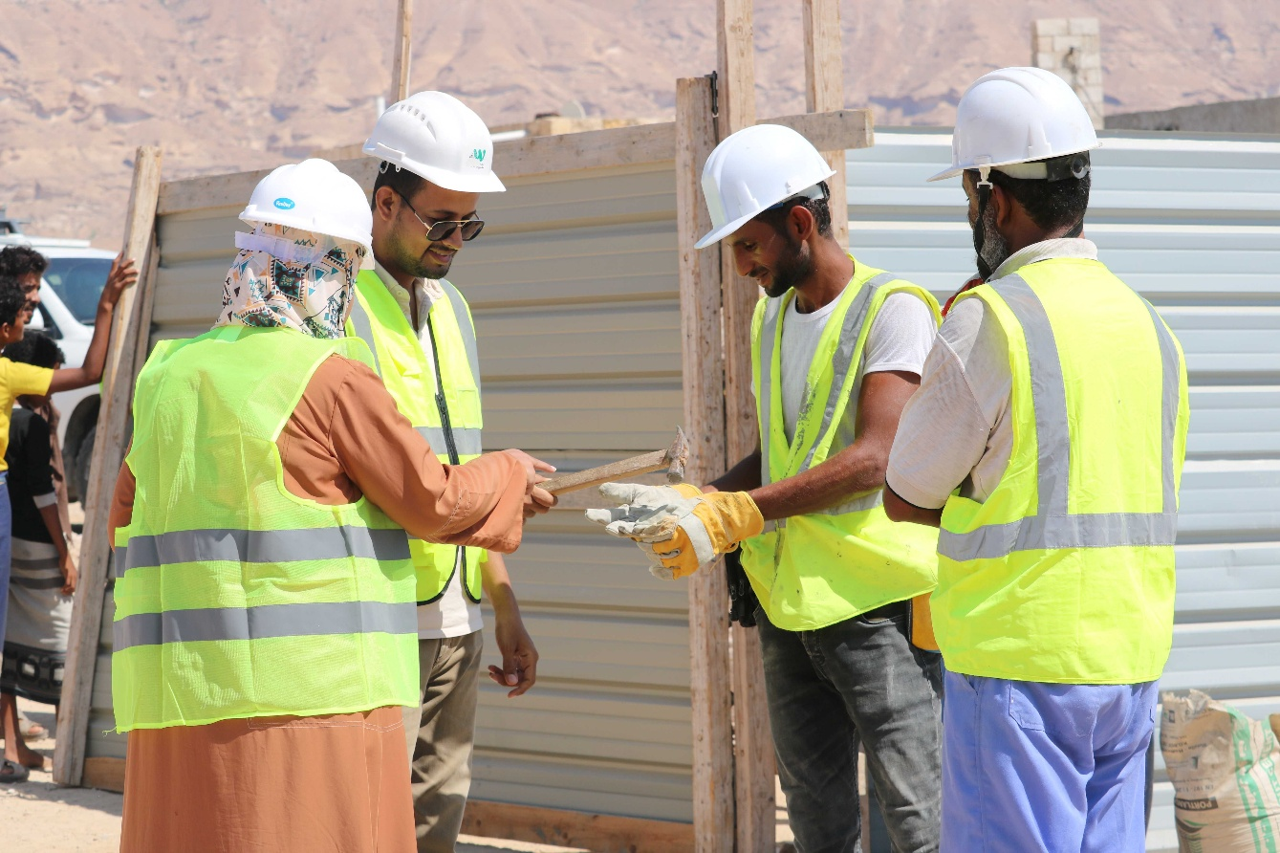
During the first quarter of 2025, UNDP aims to update its Security Management Plan in accordance with the current political and security situation in the country. UNDP provided inputs to update the respective section of the Stakeholders’ Engagement Plan of the project. Looking at the recent traffic-related accidents and incidents in the country that also affected the implementing partners, UNDP has drafted a Road Safety Plan and when cleared from the WB, it will be applicable to UNDP’s project activities.

Environmental and Social Plans and Risk Assessments
During the reporting period, UNDP and the implementing partners SFD and PWP developed and submitted a series of Social and Environmental Plans (SESP) to the WB for clearance. Table 19 shows the status of the SESP with details about the number of sub-projects and estimated costs of activities under those SESP. UNDP submitted 18 Environmental and Social Action Plans (ESAP) for review and clearance during the second half of 2024. This makes the total number of ESAPs 47, covering 187 sub-projects for the additional financing AF1. The estimated cost of activities under those sub-projects is US$24 million. The WB has cleared 38 ESAPs which includes 148 sub-projects. The estimated budget of the activities under the cleared ESAPs is US$19.5 million. 9 ESAPs covering 39 sub-projects with the cumulative estimated budget of US$ 4.6 million are under review with the WB and is expected to be cleared in the coming weeks.
For the 9 ESAPs pending clearances, UNDP has received the first round of feedback and comments from the WB on 6 ESAPs. 3 ESAP are being reviewed by the WB after the (first) submission. UNDP and the WB SES team are discussing to revisit the risk-classifications of activities which is expected to speed up the ESAP/ESRAAC clearance process. UNDP and the WB SES team will also discuss the possibilities of further simplifying the ESAP template as a step towards accelerating the ESAP clearance process.
For the sub-project with low-risk activities, the IPs developed Environmental and Social Risk Assessment and Clauses (ESRAAC). IPs submitted thirteen (13) ESRAACs during the second half of 2025. UNDP has already reviewed and cleared all ESRAACs. This makes the total number of ESRAACs cleared to 38, with the total of 77 sub-projects under AF1. The estimated cost of activities under those ESRAACs is US$ 10.6 million.

Table 19: Status of ESAPs and ESRAAC under the ESPECRP cumulatively as of 31 December 2024
Category | IP | # Plans | # sub-projects | Cost in US$ | Cleared
ESAP | SFD | 12 | 68 | $ 10,469,515 | 10
ESAP | PWP | 35 | 119 | $ 13,533,313 | 28
ESRAAC | SFD | 27 | 53 | $ 8,208,673 | 27
ESRAAC | PWP | 8 | 24 | $ 2,394,800 | 8
ESRAAC | SMEPS | 3 | Sectors | - | 3
Total |  | 85 | 264 | $ 34,606,121 | 73

The developed plans cover activities that are divided into four main categories: 45 percent agriculture sector, 26 percent road paving, 22 percent other WASH (Water and Sanitation) and 6 percent water harvesting.
Environmental and Social ESF Monitoring Indicators
The table below demonstrate the progress on the ESF monitoring indicators during the reporting period.
Table 20: Safeguard Monitoring Indicators as of 31 December 2024
Indicators | SFD | PWP | SMEPS | Total
Numbers of work Permits issued | 3,833 | 3,921 | - | 7754
Numbers of OHS and Emergency plan awareness taken place | 1,438 | 262 | 286 | 1,986
Number of GRM awareness sessions were taken place | 1,178 | 262 | 286 | 1,726
Number of awareness sessions on CoC for workers were held | 968 | 262 | 286 | 1,516
Number of gender and GBV awareness sessions provided to community members | 968 | 262 | 104 | 1,334
Numbers of field visits conducted in 2023 | 146 | 198 | 14 | 358
Number of the Community committee reports submitted to RPs | 54 | 0 | 0 | 54
Number of workers under than 18 years | 0 | 0 | 0 | 0
Numbers of incidents happened during the work | 16 | 12 | 2 | 16
The data in the table reassures that no child labor has been employed at any of the sub-projects during the reporting period. With the Work Permit as a quality control tool, the IPs ensure that the project sites meet the environmental and social standards before the commencement of work. All personnel at the sub-projects sign the Code of Conduct and ensure its adherence. IPs provide awareness sessions and trainings to enhance the capacity of consultants, contractors and workers towards the compliance of SES requirements at sub-project sites.

Accidents and Incidents:
During the reporting period, 28 incidents were reported by IPs: 16 by SFD and 12 by PWP. Among SFD's incidents, 13 were minor and treated on-site using first aid kits, while 1 was moderate, 1 a near-miss involving threats and assault, and 1 fatality due to a traffic accident outside the sub-project location during non-working hours. PWP reported 11 minor incidents treated on-site and 1 moderate incident where the individual was hospitalized. Additionally, SMEPS reported 1 near-miss involving a threat and 1 fatality of a consultant unrelated to project activities. To address these issues, UNDP has drafted a Road Safety Plan (RSP) (to be cleared by the WB) and will provide road safety and safe-driving awareness training to IP staff and consultants. The incidents occurred across multiple governorates, including Abyan, Hadramout, Hodeidah, Shabwah, Sa’dah, Dhamar, Taiz, Amran, Sana’a, Dhale, Hajjah, and Ibb. Further details are provided in the supplementary Social and Environmental Safeguard Report.

Table 21: Summary of cumulative accidents as of 31 December 2024

IP | No of SP | Working-Hours (Jul-Dec) | Working-Hours (Cumulative) | No of Accidents  (Jul-Dec) | Cumulative No of Accidents | Percentage of Accidents per W.H
PWP | 78 | 539,224 | 3,052,080 | 17 | 54 | 3.54
SFD | 61 | 4,296,684 | 7,457,676 | 14 | 30 | 0.8

Cumulatively, 80 incidents have been reported across sub-project sites, with 31 occurring at SFD sites and 49 at PWP sites. Among these, 72 were minor accidents (28 at SFD sites and 44 at PWP sites), and 8 were moderate (7 at SFD sites and 1 at a PWP site). The primary causes of these incidents were lapses in adhering to health and safety measures outlined in the ESFs and OHS guidelines. IPs and contractors have been reminded to strictly enforce OHS measures, including ensuring safe working positions and proper equipment handling. No cases of GBV or SEA were reported during the period. Additionally, three security incidents were recorded: one involving SMEPS and two with SFD, primarily related to threats and assaults.
Grievance Mechanism (GM)
a box set up close to the construction sites in Al-Qara, Ghail Bawazir, Haddramout, to receive any complaints from the community. | Photo Credit: @UNDP Yemen / 2023
UNDP printed and distributed cards containing the toll-free number (800-0939) to the three IPs and targeted beneficiaries during recent field visits. This initiative provides beneficiaries with an additional, safe, and confidential platform to voice their concerns. The call center complements the GMs already established by the IPs. Complaints are actively received through the toll-free number, and UNDP analyzes these complaints on a daily basis. Depending on the type of complaints, UNDP forwarded those to the relevant IP and followed up on their resolutions and settlements. Furthermore, meetings with IPs are conducted to discuss key complaints, review responses, and determine corrective actions, including stakeholder awareness measures and support for project-affected individuals.

During the second half of 2024, a total of 3,416 complaints were recorded—3,205 from SFD, 176 from PWP, and 35 from SMEPS. Of these, 1,673 complaints were submitted by men and 1,743 by women. Since the inception of ESPECRP, the cumulative number of complaints has reached 10,156 (9,693 by SFD, 408 by PWP, and 55 by SMEPS). Out of the 3,416 complaints received during this reporting period, 3,256 were resolved, while 160 (111 from SFD and 49 from PWP) submitted in the last quarter are pending further verification.

The GM has proven effective, with 95 percent of the 3,256 complaints resolved within the agreed timeframe of 14 days. The remaining 5 percent (137 complaints from SFD and 7 from PWP) required an extended resolution period of up to 20 calendar days. Among the unresolved complaints, 144 were under the CfN program. Of these, 10 complaints were from young health educators concerned about exclusion from the second phase dedicated to women with malnutrition, and 76 were from non-eligible women seeking clarification on their exclusion from CfN assistance. Additionally, 18 complaints came from individuals who were not selected as workers under CfW interventions. In response, SFD formed a team to conduct field visits, verify eligibility, and ensure compliance with the Project Operation Manual (POM). Furthermore, 30 complaints related to financial matters and 10 involved general inquiries.

The rising number of registered grievances indicates increased awareness among community members and stakeholders about the existing grievance mechanisms, reflecting a positive trend in engagement and accessibility.

Table 22: Complaints reported between July - December 2024 by category.
Administrative | Contractual | OHS | Ethical | Financial | General | Inclusion in selection | Social | Technical | Fraud | TOTAL
6 | 24 | 19 | 0 | 625 | 224 | 2,374 | 30 | 103 | 11 | 3,416
0.18 % | 0.77 % | 0.78% | 0.0 | 18.2% | 6.5% | 69.4 % | 0.87% | 3.0% | 0.3 % | 3,416

Notably, 69.4 percent of the complaints originated from individuals who were not selected as beneficiaries under the CfN program and other project interventions. A total of 2,300 complainants were informed that they were excluded due to ineligibility based on the project’s criteria, and these complaints were subsequently closed. However, 74 complaints received in December are still under verification to assess their eligibility for targeting. The high volume of complaints revealed a gap in community awareness regarding the selection criteria. As a result, SFD was requested to conduct additional awareness sessions in various formats to ensure better understanding and retention of the information among community members.

The remaining complaints were primarily related to financial disputes or general site issues. Approximately 18 percent of grievances were financial in nature, largely due to delays in payments caused by banking issues in Yemen. Of the 625 financial complaints received, 564 have been investigated and resolved, while 45 complaints, mostly received in December, are still under review.

Around 6.5 percent of registered grievances fell into the general category, which included inquiries about intervention types, corrections of inaccurate or misleading information, project timelines, targeting criteria, appreciation messages, suggestions, and requests for project-related information. Most of these grievances have been addressed, with only one percent still under review. Complaints in this category did not align with other specific classifications and were therefore grouped under the 'General' category.

A total of 103 technical complaints (3 percent) regarding the quality of construction work were investigated by the implementing partners' technical teams, with all but six resolved. Additionally, 11 complaints (0.3 percent) related to fraud were reported, alleging that community committee members failed to pay workers the full amount owed. All fraud-related grievances have been addressed. IP field team met the alleged members of the community committee to understand and investigate the cases. Although there were delays in payments, all workers were paid the due amount. The members of community committee were advised to inform the project manager if there are any possible delay in payments in future.

E&S Field Visits:
During the reporting period, 344 field visits were conducted (146 by SFD and 198 by PWP) to monitor compliance with safeguard instruments at sub-project locations during the implementation of activities. The UNDP team also conducted field missions to Amran, Saddah, Ibb, and Hadramout governorates to assess progress in implementation, to operationalize geobundling activities, and to monitor compliance with E&S risk management requirements.

Field visits to Amran and Saddah revealed satisfactory compliance with safeguard standards. Observations included proper waste and debris disposal in designated areas and the construction of a water line for flood protection. All workers were provided with necessary Personal Protective Equipment (PPE); however, deficiencies were noted in one project where some PPE items were unsuitable for the type of work, and certain practices did not align with safety protocols. For example, gloves provided at one site required replacement. IPs were advised to conduct more thorough training and regular OHS-focused supervision. Daily inspections by specialized OHS officers were recommended, especially for road-paving methodologies involving large stones.
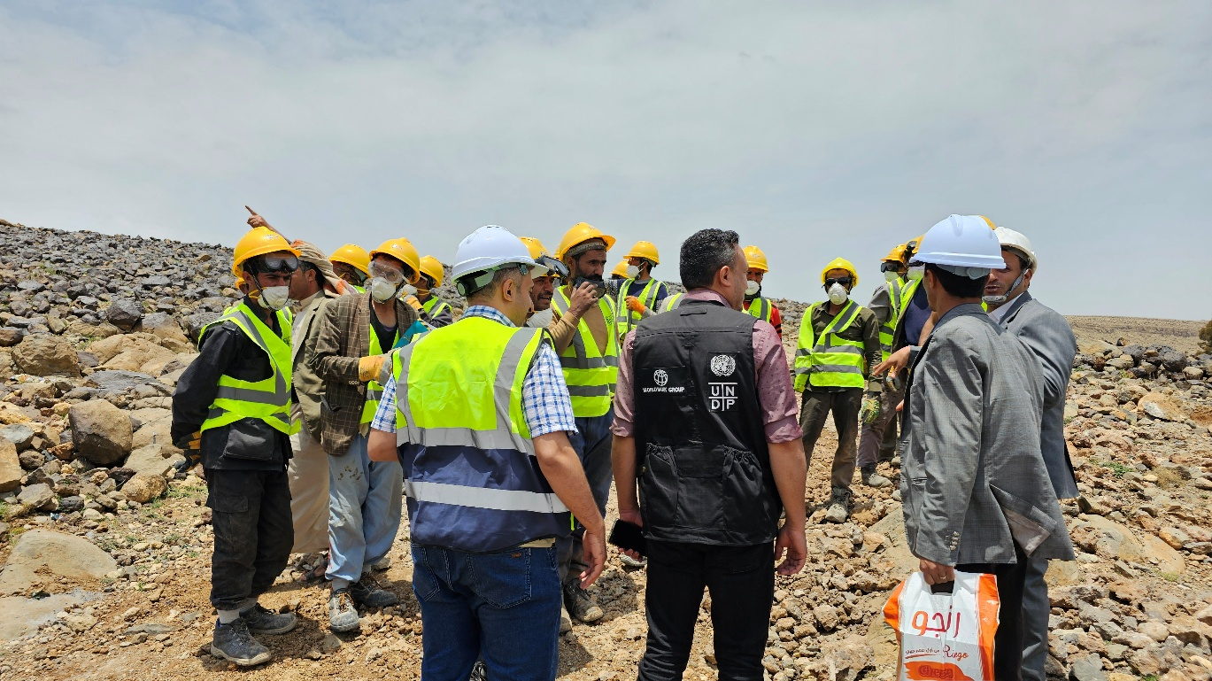

To improve field processes, IPs were encouraged to optimize time spent on geobundling and enhance the preparation of technical and safeguard studies. The site visit team also recommended the introduction of sub-project commencement permits to ensure work begins in full compliance. These permits should include quarry inspections and investigations to verify requirements. Additionally, all site visitors were advised to adhere to PPE requirements. Delays in ESAP clearances were identified as a major impediment to timely intervention commencement, affecting the impact of geobundling activities.

During field visits to Lahj and Taiz governorates, the monitoring team observed that workers were provided with PPE, and traffic management procedures were effectively implemented for pavement projects. However, damaged gloves and safety boots required immediate replacement. IPs were instructed to ensure the provision of appropriate PPE for the tasks at hand. To enhance documentation, IPs were also advised to include inspector signatures in the relevant forms.

One significant concern raised by the IPs was the delay in clearing ESAPs. These delays have caused dissatisfaction among communities and local authorities and led to resource losses, particularly in season-dependent sites. Delays in the construction of the flood protection walls due to late ESAPs clearance led to the loss of the agriculture lands and the crops in affected areas. Similarly, irrigation dependent crops could not benefit from the subproject due to delays in constructing water barriers and reservoirs.

However, the efficiency of ESAP clearance process has improved compared to past years with notable reduction in the number of review-days. UNDP and the WB discussed about the delays in several meetings and recommendations have been implemented. UNDP has prepared a comment matrix including all comments from the WB on ESAPs reviewed before, ensuring new submissions address these comments beforehand. Moreover, the monthly projections about the submission of the new ESAPs has helped UNDP and the WB plan the review process. During the ISM last October, UNDP and the WB discussed about further simplifying the ESAP template to further accelerate the clearance process. This action is expected to be completed before the next ISM in April 2025.

Capacity Building Activities
The UNDP safeguard team conducted a session on OHS as well as environmental and social safeguard standards during the geobundling workshop on 15-16 December 2024. This session aimed to raise awareness among staff at branch offices and enhance their expertise in OHS management, including risk assessment, monitoring, and control measures. Additionally, the workshop featured a session on mainstreaming gender throughout the project lifecycle. It outlined a gender-sensitive approach to expand participants' understanding of gender considerations and measures for ensuring greater gender integration in project activities.

Furthermore, a one-day workshop was organized to present gender analysis findings and discuss the challenges that hinder women’s participation, particularly under CfW interventions. The workshop explored practical solutions to bridge these gaps and emphasized the importance of leveraging the geobundling approach to strengthen partnerships, foster close coordination across project components, and maximize the impact of gender mainstreaming for long-term sustainability. In addition to these initiatives, the UNDP safeguard team actively participated in geobundling meetings, guiding discussions on safeguard measures aligned with the geobundling approach. The team also provided site-specific recommendations to expedite the preparation of social and environmental studies for the selected sub-districts. The following table shows the cumulative status of E&S risk management capacity building provided by SFD, PWP and SMEPS for different target groups:

Table 23: Safeguards Training and Awareness Raising Breakdown
Trained Parties | SFD |  |  | PWP |  |  | SMEPS
Trained Parties | M | F | Total | M | F | Total | M | F | Total
Consultant engineers and Safeguard officers | 291 | 5 | 296 | 52 | 4 | 56 | 32 | 11 | 43
Resident Engineer | 279 | 10 | 289 | 72 | 3 | 75
Workers /Direct beneficiaries | 28782 | 11,268 | 40,050 | 1,499 | 67 | 1,566
Community Committees | 1060 | 283 | 1,343 | 2,271 | 959 | 3,230 | 171 | 72 | 243
Total | 30,412 | 11,566 | 41,978 | 3,894 | 1,033 | 4,927 | 203 | 83 | 286

Stakeholder Engagement Plan (SEP) and its implementation status
Stakeholder consultations were conducted at the community level for both planned and ongoing sub-projects. These consultations included the participation of relevant local authorities, and community committees were established in all targeted locations to strengthen community engagement and participation.
A total of 10,703 community members, of whom 43 percent were women, attended public consultations. Additionally, 124 community committees were formed, comprising 1,192 members, 35.5 percent of whom were women. The community committees were tasked with playing a pivotal role in assessing community needs and contributing to decision-making processes. Several awareness-raising sessions were conducted on key topics, including gender equality, GBV, PSEA, and other safeguard-related issues. These sessions were provided to community committee members, staff, contractors, and consultants to enhance their understanding and capacity to effectively address these critical concerns.
Gender and Gender Equality
Visible progress has been achieved in increasing women’s participation across various project activities, particularly in community contracting. Since the inception of the ESPCRP activities, 12 women have been engaged as community contractors, 136,798 mothers and 4,535 health educators have participated, and 903 women-led SMEs have received support. Additionally, 904 children with disabilities were targeted during the reporting period. Noticeable synergies have been developed to enhance sustainability for women beneficiaries through the geobundling methodology. For instance, many women involved in CfN and CfW initiatives were also included in VSLAs and encouraged to adopt E-wallets. To further promote the inclusion of women and people with disabilities (PWDs), discussions were held with IPs to identify suitable CfW activities that support their involvement in ESPECRP interventions.
Furthermore, specific meetings with the WB and SMEPS explored barriers hindering women’s participation as entrepreneurs and identified actionable strategies to increase their inclusion. Proposals were also developed to involve women in microwork initiatives and to enhance the targeting of women refugees. As part of its social safeguard efforts, UNDP reviewed the institutional policies and guidelines of the IPs to ensure that effective measures are in place to prevent and address cases of SEA. UNDP also assessed the capacity of the IPs to respond to such issues and provided support to enhance their SEA/PSEA Standard Operating procedures (SOPs) and policies.
Despite these efforts, challenges remain, particularly in northern regions where cultural sensitivities and conservative norms present barriers to building the skills required to handle and investigate SEA cases professionally while maintaining strict confidentiality. To address these challenges, operational principles for the GRM were developed to guide the reporting and resolution of complaints. These principles place strong emphasis on addressing SEA/SH grievances, ensuring that all cases are reported through designated referral systems and resolved via appropriate complaint mechanisms.
Gender Mainstreaming Activities by the IPs
SFD: During the reporting period, SFD conducted training sessions on gender mainstreaming and GBV/SEA prevention. These sessions targeted 75 staff members (58 men and 17 women) and 296 consultant engineers (291 men and 5 women). Additionally, 968 awareness sessions on Code of Conduct (CoC) and social safeguards, with a specific focus on PSEA risks and mitigation measures, were delivered. These sessions reached 289 resident engineers (279 men and 10 women), 431 contractors (425 men and 6 women), 40,050 workers (28,782 men and 11,268 women), and 1,343 community committee members (1,060 men and 283 women). SFD also provided an intensive PSEA mitigation training to 40 employees of the Taiz branch office (31 men and 9 women).
Public consultations were conducted with 8,196 community members (4,522 men and 3,674 women) participating, leading to the establishment of 80 community committees with 698 members, 43.5 percent of whom were women. SFD has made significant efforts to engage women beneficiaries in supportive and gender-friendly activities, prioritizing the protection of women and children at worksites. Gender-sensitive measures, such as flexible working hours, were implemented to enhance participation.
During the reporting period, 22 field visits were conducted to monitor progress, focusing on gender mainstreaming, women’s participation, satisfaction, and safety. Interviews with 148 women workers revealed that all felt their workplaces were safe. Additionally, 84.46 percent stated that their concerns were addressed, 82 percent confirmed receiving adequate facilities to perform their tasks, 99 percent participated in project needs assessments, and 98.65 percent acknowledged attending awareness sessions on GRM and complaint reporting procedures.
PWP: During the reporting period, PWP conducted 179 awareness and training sessions on gender and GBV/SEA prevention and mitigation measures. These sessions targeted 56 consultants (52 men and 4 women), 75 resident engineers (72 men and 3 women), 1,566 workers (1,499 men and 67 women), and 3,230 community committee members (2,271 men and 959 women).
Additionally, 79 public consultations were held, involving 2,328 community members (1,393 men and 935 women). As a result, 42 community committees were established, comprising 291 members, including 106 women. These committees play a strategic role in assessing community needs and supervising project implementation. PWP has made concerted efforts to increase women’s participation as social and technical consultants and community contractors. A total of 42 women were appointed as engineers and technical consultants overseeing project implementation, 12 women were engaged as community contractors, and 51 women were employed as workers under the project interventions.
SMEPS: SMEPS conducted focused training sessions on gender mainstreaming and GBV/SEA prevention and mitigation measures, targeting 35 consultants (29 men and 6 women). Training on the GRM was also delivered to 43 consultants (32 men and 11 women) across various project activities, including livelihoods, entrepreneurship, and the private sector.
Awareness sessions on SEA prevention measures and complaint reporting mechanisms reached 312 beneficiaries (226 men and 86 women) involved in entrepreneurship and private sector activities. Two consultation sessions were held in Marib and Hadramout, with 179 participants (175 men and 4 women). Additionally, two community committees were formed, comprising 203 members (189 men and 14 women), who were tasked with assessing community needs and monitoring project implementation. A total of 62 consultants, 24 percent of whom were women, were employed during this period. Furthermore, 249 women received PPE, including 200 livestock breeders, 48 midwives, and 1 entrepreneur.
To further enhance women’s participation under the entrepreneurship activity, SMEPS held meetings with UNDP and the WB to identify barriers to women’s involvement. These discussions led to actionable proposals aimed at increasing the targeting of women refugees and involving women in microwork interventions.

Communication & Visibility Plan

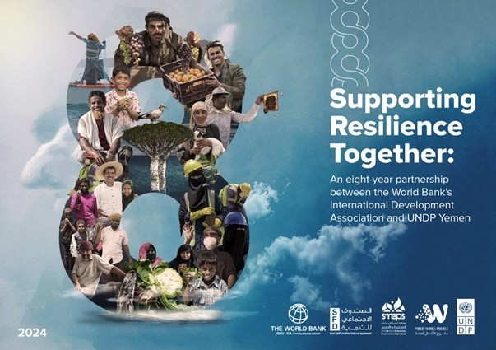
Since 2016, UNDP has partnered with the WB’s International Development Association to address immediate needs while fostering long-term food security resilience in Yemen. To mark eight years of this impactful collaboration, UNDP Yemen launched a social media campaign celebrating the partnership's contributions to improving the lives of Yemeni people and communities.

As part of the campaign, a booklet in both Arabic and English was published, featuring inspiring stories of resilience and impact. These stories highlight the extraordinary determination of Yemeni people in the face of immense challenges. Additionally, six short videos were published to showcase the key achievements of YECRP, ESPECRP, FSRRP, and SFISH, emphasizing their tangible impact on building stronger and more self-resilient communities.

For the International Women’s Day, Rural Women’s Day, 16 Days of Activism during 2024, ESPECRP was celebrated for investing in women to help benefit families and entire communities. For example, UNDP Yemen featured the inspiring story and video of Entisar who turned her love of sewing into an income-generating business in her village, Wesab, Dhamar.

Entisar’s story highlights ESPECRP’s support to establishing Village Savings and Loan Associations (VSLAs) in rural villages by SFD which operate on a simple financial model: members of these VSLAs contribute a set amount each month, creating a pool of funds that is then used to finance their individual projects on rotation. This model aims to launch specific small businesses that not only benefit the owners, but also help provide rural communities with local goods and services they need, and at affordable prices. Most Yemenis living in rural areas do not have access to any financial services due to the absence of banks and microfinance institutions. This makes it difficult for people to get funding to start income-generating activities.

With support from the WB’s IDA, UNDP Yemen and SFD featured an exposure story (Arabic, English, French, and Spanish ) and video about VSLAs created to help Yemenis in rural Yemen save their money and secure financing for their small businesses to improve their income and livelihood. These VSLAs are effective at enhancing food security resilience and reducing poverty, helping Yemenis living in rural communities lead dignified lives, and supporting their resilience.
On World Youth Day, UNDP Yemen published a video featuring young Yemeni entrepreneurs supported by ESPECRP with financial and technical assistance to start, run, and grow their businesses in health, green tech, and agrobusinesses and more. By providing the tools and resources necessary to turn ideas into impactful businesses, ESPECRP has helped youth not only achieve economic resilience but also contribute to addressing local needs and driving community resilience. These initiatives underscore the vital role of youth as catalysts for innovation and progress in Yemen’s recovery and development journey.

As malnutrition is the leading cause of child mortality in Yemen, with nearly 2.2 million children under the age of five suffering from acute malnutrition, UNDP Yemen published Ashjan’s exposure story, highlighting ESPECRP’s support to providing emergency cash for mothers with children at risk of malnutrition – as well as pregnant women – through SFD’s CfN subcomponent to access healthcare and purchase nutritious food for themselves and their children. These mothers are also educated on proper health and nutrition practices by young women who are trained as health educators and paid monthly incentives to help them take care of their children to grow healthy and strong.

On #WorldBeeDay, UNDP Yemen featured two videos of its partnership with the World Bank’s IDA to support Yemeni beekeepers and the crucial role they play in protecting bees and producing high quality honey. For centuries, honey production has been a significant part of Yemen’s heritage, communal pride, and source of income for many. Also, UNDP Yemen published an animation video illustrating ESPECRP’s support to food supply chains contributing to building resilient local food markets & systems in Yemen.

During this reporting period, UNDP Yemen also published two explainer animation videos to highlight ESPECRP’s area-based approach where multisector interventions are implemented to ensure complementarity and maximize impact to tackle the different drivers of food insecurity and malnutrition in Yemen.

As of December 2024, UNDP - with SFD, SMEPS, and PWP - has published forty-five videos and animations highlighting ESPECRP’s work and impact, garnering over 125,512 views online. In addition, 391 main social media posts have been published so far (9,979+ likes; 2,000+ shares) with 343,029+ views.

Key Actions/Activities for the Next Reporting Period (January to June 2025)

The table below summarizes the key actions that IPs and UNDP plan to complete by the end of the next reporting period in June 2025:
Subcomponent / RP | Actions
COMPONENT 2
2.1 Cash for Nutrition | - Under AF, SFD will:  - Complete the cash assistance to all the target women, and most of the malnutrition cases in two districts (Hamdan and AlHusha).  - Under AF2:  - Finalize the HH surveys in the remaining six subdistricts and train the remaining women community educators.  - Coordinate closely with VSLAs and the other relevant activities for geobundling.  - Complete the cash assistance in 14 subdistricts and follow up on the referral services.
2.2 Cash for Work / SFD | - SFD will complete the implementation of the 105 ongoing sub-projects and the 29 new ones under the AF.  - Under AF2, SFD will finalize the technical studies and safeguard plans for around 150 sub-projects and will progress the implementation of the ongoing ones.  - SFD will continue supervising the quality of implementation, will ensure compliance to safeguards, and actively contribute to the operationalization of the geobundling approach.
2.3 Community Assets/ PWP | - Under AF, PWP will proceed with the implementation of 79 sub-projects under the AF and finalize the preparation of the safeguard plans for the remaining sub-projects.  - Under AF2, PWP will finalize the technical studies and safeguard plans of 100 sub-projects.  - PWP will continue supervising the implementation and ensure compliance to safeguards as well as geobundling requirements.
2.4(a) YLG Subgrant, VSLAs, MFI Support / SFD (SMED) | - SMED will mobilize and promote local communities in 50 new target areas, and create 100 new VSLAs.  - SMED will build the capacity of 2,000 new and existing VSLA members, and support 300 current VSLA members to start or expand income-generating activities or MSMEs.  - SMED will update the grant manuals to reflect the new additional finances including the AF3 once confirmed.
2.4(b)MSMEs (Farmers, Fishermen, Livestock), BAs SMEPS | SMEPs will:  - Train 28 business advisors, 200 entrepreneurs, and 5 incubators as well as a number of consultants in health sector.  - Complete the grants and technical assistance for 181 entrepreneurs and organize events to link entrepreneurs with financial institutions and investors.  - Complete the formation of production groups, linking them to the Giving financial support to 141 rural clinics (midwives).  - Providing a training program for consultants in the health sector in the northern regions.  - Complete disbursing the grant for 38 SMEs and 10 FCs.  - Enhance women participation by applying additional measures, and work with UNDP and the WB on preparing proposals to support refugees and pilot microworks.
COMPONENT 3: Component 3: Project Management, Monitoring, Evaluation and Capacity Building of National Institutions
UNDP | - UNDP will follow up on and complete the agreed actions of the last ISM.  - UNDP will conduct two TPM missions as well as two project team field visits to a sample of sites and will submit the reports on time, as per the financing agreement.  - UNDP will continue the implementation of the institutional capacity building (ICB) plans for the IPs.  - UNDP will continue guiding and enhancing the monitoring of the geobundling process to enhance the coordination and generate evidence and lessons learned.  - On communication and visibility, UNDP – in collaboration with SFD, SMEPS, and PWP - plans to publish the following:  - A blog highlighting ESPECRP’s geobundling approach to maximize and sustain impact of food and nutrition security.  - An explainer animation on how ESPECRP’s supported Village Savings and Loan Association are created to enhance food security resilience through improving access to finance and income-generating activities in rural communities.  - Featuring a story and video about ESPECRP’s support to women on International Women’s Day.  - A results video will be published to highlight ESPECRP’s overall achievements.  - UNDP will prepare for the upcoming ISM (tentatively April 2025) with the IPs and the WB.

Risk Framework and Risk Mitigation Measures

Systematic Operations Risk-Rating Tool
Risk Category | Rating | Update
Political and Governance | High | - A major security incident occurred in early June, involving the detention of several UN and I/NGO staff by DFA security forces. Despite substantial progress in negotiations, not all detainees have been released. Alarmingly, additional detentions took place on 16 January 2025. In response, UN Agencies have announced the immediate suspension of movements in DFA-controlled areas. Intense lobbying efforts are underway to secure the immediate release of the detained personnel. The situation remains fluid and unpredictable, and UNDP will continue to monitor developments closely and keep donors informed.  - DFA forces have targeted shipments in the Red Sea as a pressure tactic to end the Israeli aggression in Gaza. While the risk has decreased following the recent ceasefire agreement with Israel, the situation remains a cause for concern. UNDP will maintain vigilance and adapt operations as necessary to ensure safety and continuity.
Macroeconomic | High | - The banking system in the North continues to face significant challenges, compounded by the persistent devaluation of the Yemeni Riyal in the South. These issues have had widespread implications on the overall stability of the project.  - The loss attributed to the Special Drawing Rights (SDR) exchange has increased since the last report, now totaling approximately $10 million of the combined budget for AF and AF2. This deficit has necessitated the cancellation of certain sub-projects, adversely impacting the results framework and the achievement of planned outcomes.
Technical Design of Project or Program | Substantial | - The GB approach has raised concerns among authorities over unequal fund distribution and caused delays due to extensive coordination and community engagement, risking dissatisfaction. To address these challenges, UNDP and the IPs are ensuring transparent communication with authorities, coordinating with other donors to expand support, and allocating resources for community monitoring and social cohesion to maximize the approach’s impact.
Institutional Capacity for Implementation and Sustainability | Medium | - Data collection and sharing with international agencies in DFA areas have become increasingly risky. Apex, the TPMA for ESPECRP, continues operations with survey tools limited to essential technical data, avoiding open questions. While sub-district needs assessments for geobundling are nearly complete, restrictions have delayed the IFPRI impact evaluation. Movement of women personnel also remains restricted. The WB has discussed the implications of these challenges on project operations and agreed to explore sensitive monitoring methods that prioritize safety.
Fiduciary | High | - Political and security escalations, coupled with the banking crisis, have posed risks to fiduciary areas such as finance, procurement, TPM verification, and ESF safeguards. UNDP has closely monitored these challenges and engaged with the World Bank to explore alternative strategies. Thus far, no major impact has been observed, as interventions by the UN and other actors have mitigated recent escalations. Regular measures, including internal controls, spot checks, TPM verifications, and field visits, have ensured compliance. Over nine years of collaboration with the World Bank, fiduciary performance, including IFRs and procurement, has remained satisfactory. Additionally, IPs' institutional capacities have been strengthened in financial systems, internal controls, data management, and safeguards.
Environment and Social | Substantial | - Social risks, such as the exclusion of vulnerable groups, GBV, grievances, child labor, land disputes, and community health issues, remain prevalent in fragile and conflict-affected contexts like Yemen. Additionally, while most of ESPECRP’s interventions are relatively small, occupational health and safety risks persist, particularly as many CfW workers are unskilled. The project design incorporates measures to mitigate these risks and mandates strict compliance with updated ESF requirements. Significant progress has been made in strengthening the safeguard capacities, resources, and systems of IPs and UNDP. Regular TPMA verifications and UNDP field visits have been conducted to ensure compliance and improve ESF safeguards. However, the safeguard preparation and clearance process has been lengthier than necessary, causing delays, community dissatisfaction, and reputational risks. In response, UNDP and the World Bank are collaborating to streamline the process and reduce clearance time to approximately two weeks.
Stakeholders | Substantial | - Detentions in DFA-controlled areas have significantly endangered national personnel, posing operational challenges. Despite these risks, UNDP and IPs have maintained activities by, inter alia, adopting conflict-sensitive communication strategies. The longstanding neutrality and trust national IPs have built with local authorities and communities over two decades have been instrumental in ensuring operational continuity and mitigating these risks.
OVERALL | High

ANNEXES:

Annex 1: Results Framework

PDO Level Indicators | (IPs) | Unit | Baseline | Total Targets PF+AF+AF2 | Progress as of (31 Dec. 2024) | % results vs targets
Provision of Cash Transfers
Number of beneficiary households benefitting from the cash for nutrition program | SFD | Number | 0 | 106,500 | 126,726 | 119%
Number of beneficiary households (Social Welfare Fund) | SFD | Number | 0 | 9,300 | 8,146 | 87.6%
Number of beneficiaries (women) | SFD | Number | 0 | 111,600 | 136,798 | 122.6%
Number of beneficiaries (children) |  | Number | 0 | 153,000 | 200,209 | 130.9%
Provision of temporary employment
Number of direct beneficiaries of wage employment | SFD & PWP | Number | 0 | 155,208 | 92,718 | 59.7%
Number of beneficiaries (women-at least 20%) | SFD & PWP | Number | 0 | 33,710 | 25,228 | 74.8%
Number of beneficiaries (IDPs - at least 15%) | SFD & PWP | Number | 0 | 22,281 | 8,262 | 37.1%
Increased access to basic services and economic opportunities to vulnerable populations
Number of people with increased access to basic services | SFD & PWP | Number | 0 | 1,122,880 | 957,879 | 85.3%
Of which, women (at least 50%) | SFD & PWP | Number | 0 | 528,397 | 478,940 | 90.6%
Number of Micro, Small and Medium Enterprises (MSME's) supported by the Project | (SMEPS & SMED) | Number | 0 | 10,009 | 7,819 | 78.1%
Number of women-led SMEs supported by the project (at least 35%) | (SMEPS & SMED) | Number | 0 | 2,778 | 903 | 32.5%
People provided with access to improved sanitation services to reduce water-borne diseases exacerbated by climate change | SFD & PWP | Number | 0 | 272,845 | 103,030 | 37.8%
Intermediate Results Indicators by Subcomponents
Subcomponent 2.1: Cash Transfers (Cash for Nutrition)
Number of women beneficiaries of wage employment | SFD | Number | 0 | 3,920 | 4,535 | 115.7%
Number of indirect beneficiaries of wage employment | SFD | Number | 0 | 23,520 | 26,382 | 112.2%
Subcomponent 2.2: Labor Intensive Works and Economic Opportunities
2.1 Cash for Work (SFD)
Number of direct beneficiaries of wage employment | SFD | Number | 0 | 77,700 | 43,009 | 55.4%
Number of beneficiaries (women) (30%) | SFD | Number | 0 | 23,310 | 13,985 | 60.0%
Number of indirect beneficiaries of wage employment (family members of direct beneficiaries) (cash for work) | SFD | Number | 0 | 372,312 | 178,389 | 47.9%
Number of people with increased access to basic services | SFD | Number | 0 | 452,750 | 384,790 | 85.0%
Cubic meters of water schemes constructed/rehabilitated (Cubic Meter(m3)) | SFD | m3 | 0 | 46,066 | 14,188 | 30.8%
Area of agriculture land rehabilitated Hectare | SFD | ha | 0 | 2,477 | 2,040 | 82.4%
Length of roads improved (Kilometers) | SFD | km | 0 | 209 | 149 | 71.3%
Subcomponent 2.3: Community Assets (PWP)
Number of direct beneficiaries of wage employment | PWP | Number | 0 | 51,993 | 18,926 | 36.4%
Number of women beneficiaries (3%) | PWP | Number | 0 | 2,167 | 655 | 30.2%
Number of indirect beneficiaries of wage employment | PWP | Number | 0 | 311,958 | 113,556 | 36.4%
Number of people with increased access to basic services | PWP | Number | 0 | 670,130 | 573,089 | 85.5%
Cubic meters of water schemes constructed/rehabilitated (Cubic Meter(m3)) | PWP | Number | 0 | 147,402 | 72,106 | 48.9%
Area of agriculture land rehabilitated Hectare | PWP | Number | 0 | 5,012 | 2,922 | 58.3%
Length of roads improved (community assets) (Kilometers) | PWP | Number | 0 | 163 | 57 | 35.1%
2.4a Increased Access to finance for MSMEs (SFD/SMED)
Number of MFIs to access the new YLG portfolio guarantee scheme | SFD (SMED) | Number | 0 | 6 | 6 | 100.0%
Number of SME loans guaranteed by the new capitalization to the YLG | SFD (SMED) | Number | 0 | 3,754 | 4,560 | 121.5%
Number of Village Saving and Loans Associations | SFD (SMED) | Number | 0 | 715 | 597 | 83.5%
2.4b Direct support to MSMEs and business associations in critical sectors (SMEPS)
SMEs receiving TA and grants that produce and facilitate food distribution | SFD (SMEPS) | Number | 0 | 6,255 | 3,233 | 51.7%
Business associations supported in the target sectors directly through grants and TA | SFD (SMEPS) | Number | 0 | 50 | 55 | 110.0%
Number of new seasonal and permanent wage employment supported | SFD (SMEPS) | Number | 0 | 21,595 | 26,248 | 121.5%
Component 3: Project Management, Monitoring, Evaluation and Capacity Building of National Institutions
Surveyed beneficiaries who report receiving the right payment amount | UNDP | % | 0 | 98 | 100
Grievances received, addressed, and responded to within a timeline that has been specified and publicly communicated by the project | UNDP | % | 0 | 90 | 95
Surveyed beneficiaries who express satisfaction with project interventions (UNDP) (Percentage) | UNDP | % | 0 | 80 | 91
Capacity building action plan for SFD adopted and implemented | UNDP | Yes/No | No | Yes | In progress
Capacity building action plan for PWP adopted and implemented | UNDP | Yes/No | No | Yes | In progress

Annex 2: Annual Progress (Expenses and Direct Beneficiaries) per Subcomponent

Subcomponent | 2021 |  | 2022 |  | 2023 |  | 2024
Subcomponent | Expenses | Direct Benef. | Expenses | Direct Benef. | Expenses | Direct Benef. | Expenses | Direct Benef.
CfN | 2,729,294 | Mothers= 24036  CHEs=484 | 10,967,321 | Mothers= 41101  CHEs=1252 | 11,526,193 | Mothers= 32096  CHEs=1216 | 10,172,943 | Mothers= 39565  CHEs=1583
CfW | 66,129 | 0 | 9,932,831 | 19813 | 1,792,662 | 3720 | 7,887,379 | 19476
Community Assets | 1,069,093 | 1372 | 8,641,279 | 8931 | 3,402,319 | 3723 | 4,586,327 | 4900
YLG/VSLAs/MFIs/MSMEs | 2,529,217 | MSMEs= 267  VSLAs=31 | 4,177,026 | MSMEs= 3397  VSLAs=0 | 2,088,991 | MSMEs= 1435  VSLAs=223 | 3,530,461 | MSMEs= 2749  VSLAs=343
Goods, works, consulting, non-consulting, Operating Costs | 4,916,050 |  | 8,014,521 |  | 10,671,443 |  | 11,041,446

Annex 3: ESPECRP ISM 29 – 31 October 2024: Actions and Status of Progress

# | Key Action | Resp. | Timeline | Progress Status
Corporate Issues
 | Organize meeting with CCB staff for UNDP and the IPs to increase the recognition of project activities in the form of Climate Co-Benefits in future Afs | WB | January 2025 | WB to update
 | Organize meeting with WB disability inclusion team to facilitate mainstreaming disability inclusion in the project design via the next AF. | WB | January 2025 | WB to update
 | UNDP to share a revised ECA table with the WB for clearance. The approved ECA would then be reflected in the POM which would also be shared with the WB for clearance. | UNDP/WB | February 2025 | Ongoing. Will be submitted by end Feb
 | UNDP to send the WB a more detailed update on the status of detentions since June 2024. | UNDP | January 2025 | Completed
E&S
 | UNDP to ensure resolution of 49 open cases in GM | UNDP | January 2025 | Completed. All reported complaints were closed.
 | Simplify the site specific Environmental and Social Action Plan (ESAP) and their clearance processes by minimizing the duplicated information throughout all ESAPs and enhancing the Environmental and Social Management Framework (ESMF) of the Project.  Revisit the risk-rating of sub-project activities related to rural road pavement and communal or household water harvesting tanks. UNDP will submit a proposal for the WB’s review and approval | UNDP/IPs /WB | December 15, 2024 | UNDP shared a proposed ESAP simplification template with the WB.  Regarding risk-rating, UNDP, WB and IPs presented project activities associated risks during a meeting in December 2024, recommending to revisit risk-ratings.  UNDP is waiting for the final decision from the WB on both suggestions.
 | Include in the next ES report and for next ISM, anonymous feedback from women contractors and their experiences about working conditions, information on movement restrictions for women staff and consultants, and TPM updates relating to ES to triangulate monitoring by UNDP | UNDP | Next ISM | Ongoing
 | Ensure all ESMPs that are under revision and new ESMPs include adequate documentation and consultations regarding voluntary land donation as per ESS5. | UNDP | Ongoing | Ongoing
 | Include monitoring evidence of primary supply workers to confirm no child workers (site engineer to go to quarries to confirm no child labor) | UNDP | Ongoing | Ongoing
 | Discuss with UNDP the information and documentation needed to ensure voluntary land donation as per ESS5, report on the number of sub-projects that have used voluntary land donation for activities and provide confirmation that no informal land use existed on lands. | UNDP/WB | January 2025 | Delayed to May 2025 along with the delay in the WB’s training
 | Include a module on voluntary land donation in the pending ESF training planned to be held in Cairo in January 2025 | WB | January 2025 | Delayed to May 2025 tentatively due to developments in the region.
 | Develop a capacity building plan for the national IPs including strengthening reporting on incidents. | UNDP | January 2025 | An assessment is underway, and a training plan will be developed based on its findings.
 | Enhance in-house monitoring and reporting capabilities including complaints handling mechanism | UNDP | March 2025 | Ongoing
Financial Management
 | Provide information on fixed assets and aging advances in the IFR | UNDP | February 15, 2025 | Ongoing
 | Share with the WB spot-checks report. | UNDP | January 2025 | Completed
 | Provide training to IP staff on risk management | UNDP | April 2025 | Ongoing
Component Specific
- on | (Cash-for-Nutrition) Explore enabling digital payment options for Cash for Nutrition Beneficiaries | UNDP/WB/ SFD | February 15, 2025 | Ongoing
 | (Cash for Work) SFD to share with UNDP and the WB a brief outlining disability inclusion considerations, contributions and opportunities. | UNDP | Next ISM | Next ISM
 | (Cash for Work) UNDP and IPs to intensify efforts to increase gender participation in CfW activities and in the blue economy | UNDP | Next ISM | Ongoing
 | UNDP and IPs to analyze costs and benefits of supporting water barriers above 6 meters, but not greater than 15 meters, to facilitate deliberation on whether these may be supported under the project | UNDP | January 31, 2025 | Ongoing. The draft will be shared by mid February
 | UNDP will prepare and send the WB actual IPs operating costs over the project lifespan, along with projected shortfall and develop options for responding to any potential deficit | UNDP/ WB | December 20, 2024 | Initial attempts to address this action indicated that further work was needed. It’s proposed now to be submitted by the end of February 2025.
 | (Community Assets) Expedite the completion of pending sub-projects under AF and the initiation of sub-projects under AF2 | UNDP | Next ISM | Ongoing
 | (Community Assets) UNDP to further investigate the status of PWP’s vehicle fleet alongside options for addressing concerns regarding their age, operability, and high maintenance requirements. | UNDP | Next ISM | Ongoing
 | (Community Assets) Additional PWP capacity building opportunities to be explored and programmed, including on risk management | UNDP | Next ISM | Ongoing
 | (Economic Opportunities) SFD to update POMs for SMED and YLG to reflect changes introduced under AF and AF2 | UNDP | January 31, 2024 | Ongoing
 | (Economic Opportunities) SMEPs to submit the annual activities planned under the Yemen Private Sector Cluster activity for WB approval | UNDP | December 15, 2024 | Completed. If any new activities, the revised plan will be shared.
 | (Economic Opportunities) Finalize and implement a follow-up mechanism for action and course correction related to TPM reporting and findings | UNDP | February 2025 | Ongoing
Procurement
 | UNDP to share with the WB the procurement monitoring table and dashboard data on a quarterly basis. This table would be also included in the bi-annual progress reports. | UNDP | Quarterly | included in the procurement link in the procurement section
 | UNDP to share the details of the procurement complaints presented during the mission along with their resolutions with the WB. | UNDP | January 2025 | Included in the procurement link above
Communication and Outreach
 | UNDP to connect with WB’s new communications staff based in Amman | WB/ UNDP | November 30, 2024, | Completed
 | UNDP to share draft Communications Strategy with the WB communication staff | UNDP | December 20, 2024, | Completed

Annex 4: Communication and Visibility Reference Links

Title | Links
Eight-year partnership | Eight-year partnership  Promo video  X  AR: https://x.com/UNDPYemen/status/1858197036664869214  EN: https://x.com/UNDPYemen/status/1858177920730055065  Facebook  https://fb.watch/xdBWzcthop/  Booklet  AR: https://x.com/UNDPYemen/status/1869404758827778373  EN: https://x.com/UNDPYemen/status/1869389656976236558  Reels:  Building Back Better  AR: https://x.com/UNDPYemen/status/1869835163892625418  EN: https://x.com/UNDPYemen/status/1869817831589855629  Facebook  https://www.facebook.com/reel/951587353573438
Improving Agricultural Productivity for Food Security | Exposure story/UNDP Website:  AR: https://x.com/UNDPYemen/status/1870917043236798644  EN: https://x.com/UNDPYemen/status/1870816098754412874  Facebook  https://www.facebook.com/reel/929760525483460  Investing in Human Capital and Local Community  AR: https://fb.watch/xdH9xd2Fq-/  EN: https://x.com/UNDPYemen/status/1871621407475683412  Supporting climate-resilient communities  AR: https://x.com/UNDPYemen/status/1873665515677495790  EN: https://x.com/UNDPYemen/status/1873648733298311562  Facebook  https://fb.watch/xdHd8z1GNs/
Fostering Economic Resilience | AR: https://x.com/UNDPYemen/status/1874087692738453699  EN: https://x.com/UNDPYemen/status/1874056025424486447  Facebook  https://www.facebook.com/reel/622881963639699
Sustainable Fishery | AR: https://fb.watch/xdC03le9bM/
16 days of activism | Nahla’s and Sally’s story  Story  AR: https://www.undp.org/ar/yemen/stories/nhlt-wsaly-tumhwdan-altryq-llmrat-alymnyt-fy-qta-altshyyd-walbna  EN: https://www.undp.org/yemen/stories/meet-nahla-and-sally-yemeni-women-building-careers-construction  X  AR: https://x.com/UNDPYemen/status/1861042945543000121  EN: https://x.com/UNDPYemen/status/1861024083950936230
International Day of Rural Women | X  AR: https://x.com/UNDPYemen/status/1846566782368469324  EN: https://x.com/UNDPYemen/status/1846555827387474416  Facebook  https://fb.watch/xdBK7vP7wG/
World Youth Day | Video  X  AR: https://x.com/UNDPYemen/status/1823008035893113058  EN: https://x.com/UNDPYemen/status/1822992684606177782  Post  X  AR: https://x.com/UNDPYemen/status/1822576785705361765  EN: https://x.com/UNDPYemen/status/1822563057496633345
Explainer animation on enhancing food supply chains | X  AR: https://x.com/UNDPYemen/status/1815295342264418633  EN: https://x.com/UNDPYemen/status/1815276729511854267  Facebook  https://fb.watch/xdBeWJXKTP/
World Bee Day | X  AR:  https://x.com/UNDPYemen/status/1792486683335692338  https://x.com/UNDPYemen/status/1793018426413162971  EN:  https://x.com/UNDPYemen/status/1792473707350310996  https://x.com/UNDPYemen/status/1793003327183335433
Microfinancing through Village Savings and Loan Associations (VSLAs) | Exposure story:  English: https://stories.undp.org/microfinancing-powers-small-businesses-in-rural-yemen  French: https://stories.undp.org/la-microfinance-dynamise-les-petites-entreprises-rurales-du-yemen  Spanish: https://stories.undp.org/la-microfinanciacin-comunitaria-brinda-esperanza-al-yemen  X:  https://x.com/UNDPYemen/status/1790996383958253751  https://x.com/UNDP/status/1791680110644670594  https://x.com/UNDP/status/1792525684818284766  https://x.com/pnudfr/status/1792434327709499613  https://x.com/pnud/status/1792664039245615344  https://x.com/pnudfr/status/1793577611131535476  https://x.com/UNDP/status/1793552451477369339  https://x.com/pnudfr/status/1794680880926953953  English: https://x.com/UNDP/status/1790894937279483904  Arabic: https://x.com/UNDPYemen/status/1791008224969166849
World Day for Safety and Health at Work | X  Arabic: https://x.com/UNDPYemen/status/1784502060051812514  English: https://x.com/UNDPYemen/status/1784486711579275634
Entisar’s exposure story (International Women’s Day) | AR: https://www.undp.org/ar/yemen/stories/ksr-hlqt-alfqr-fy-almnatq-alryfyt-fy-alymn-qst-antsar-knmwdhj-lltmkyn-alaqtsady  EN: https://www.undp.org/yemen/stories/breaking-cycle-poverty-rural-yemen-entisars-story-economic-empowerment  X  AR:  https://x.com/UNDPYemen/status/1766904857753993532  https://x.com/UNDPYemen/status/1767075482770780214  EN:  https://x.com/UNDPYemen/status/1766892602714960244  https://x.com/UNDPYemen/status/1767060382399828471  Facebook:  https://fb.watch/rC4b15M-Ku/  YouTube: https://www.youtube.com/watch?v=h65x6PwSDu0
Geobundling animation | X  AR: https://x.com/UNDPYemen/status/1765410740926660771  EN: https://x.com/UNDPYemen/status/1765400416949318012  Facebook:  https://fb.watch/rC439-s8En/
ESPCRP’s achievements | X  AR: https://x.com/UNDPYemen/status/1765018255813452053  EN: https://x.com/UNDPYemen/status/1764997450039709801  Facebook:  https://fb.watch/rC3ZUdKL8H/  https://fb.watch/rC40-uFaoN/
Ashjan’s exposure story (Cash for Nutrition) | AR: https://undpyemen.exposure.co/especrp-ashgan-malnutrition-ar  EN: https://undpyemen.exposure.co/especrp-ashgan-malnutrition  X  AR: https://x.com/UNDPYemen/status/1752743545146905088  EN: https://x.com/UNDPYemen/status/1752727690795471049  YouTube: https://www.youtube.com/watch?v=qZE5LzktBk0  https://x.com/UNDPArabStates/status/1753102409952547126
Supporting food security (Marib’s video) | X  AR: https://x.com/UNDPYemen/status/1746832473219297339  EN: https://x.com/UNDPYemen/status/1746814982782583235
ESPECRP’s explainer animation | X  EN: https://x.com/UNDPYemen/status/1744396042106470548  AR: https://x.com/UNDPYemen/status/1744416174157549737  Facebook:  https://fb.watch/rC3roVwW12/
Combating Food Insecurity and Malnutrition Amidst Multiple Challenges | Arabic: https://www.albankaldawli.org/ar/news/feature/2023/12/13/combating-food-insecurity-and-malnutrition-amidst-multiple-challenges?cid=ecr_tt_worldbank_ar_ext  English : https://www.worldbank.org/en/news/feature/2023/12/13/combating-food-insecurity-and-malnutrition-amidst-multiple-challenges  X : https://x.com/AlbankAldawli/status/1741066672268615891
Other highlights | https://x.com/UNDPYemen/status/1857010598350876728  https://x.com/UNDPYemen/status/1857040006268813619  https://x.com/UNDPYemen/status/1851610081663623355  https://x.com/UNDPYemen/status/1851640976739119283  https://x.com/UNDPYemen/status/1851278272606216523  https://x.com/UNDPYemen/status/1851308529094733913  https://x.com/UNDPYemen/status/1849009433965183431  https://x.com/UNDPYemen/status/1849031763651121575  https://x.com/UNDPYemen/status/1848634384229831085  https://x.com/UNDPYemen/status/1848658252378095752  https://x.com/UNDPYemen/status/1847623756472070503  https://x.com/UNDPYemen/status/1847641351363453133  https://x.com/UNDPYemen/status/1846596973186449803  https://x.com/UNDPYemen/status/1846612073901707438  https://x.com/UNDPYemen/status/1829245851862188429  https://x.com/UNDPYemen/status/1829260069655257116  https://x.com/UNDPYemen/status/1828167699874091342  https://x.com/UNDPYemen/status/1828331379689390555  https://x.com/UNDPYemen/status/1796769644491182353  https://x.com/UNDPYemen/status/1796753541559922718  https://x.com/UNDPYemen/status/1796202409565560967  https://x.com/UNDPYemen/status/1796218509212455183  https://x.com/UNDPYemen/status/1795344307622433006  https://x.com/UNDPYemen/status/1795358538598117460  https://x.com/UNDPArabic/status/1768341323088642439  https://x.com/UNDPYemen/status/1759120663565021355  https://x.com/UNDPYemen/status/1759160675698344174  https://x.com/UNDPYemen/status/1772217696463028573  https://x.com/UNDPYemen/status/1772243015601373287  https://x.com/UNinYE/status/1760175014786277672  https://x.com/UNDPYemen/status/1746027793488777305  https://x.com/UNDPYemen/status/1746043396039540744v  https://x.com/UNDPArabStates/status/1745409469071192353  https://www.worldbank.org/en/news/immersive-story/2023/09/18/food-system-resilience-in-the-middle-east-and-north-africa?cid=mena_tt_mena_en_ext  https://x.com/WBG_IDA/status/1742660911637090329  https://x.com/UNDPYemen/status/1744611015013126497  https://x.com/UNDPYemen/status/1744627776966070573  https://x.com/UNDPArabic/status/1745410978982797744  https://x.com/UNDPYemen/status/1750904256591237251  https://x.com/UNDPYemen/status/1750919526454370438  https://x.com/UNDPYemen/status/1754203166059512310  https://x.com/UNDPYemen/status/1754218267550601254  https://x.com/UNDP/status/1762273843098550436  https://x.com/UNDPArabStates/status/1762468626140189040  https://x.com/UNDPArabStates/status/1761806261715345692  https://x.com/pnudfr/status/1764541283358458262  https://x.com/UNDPYemen/status/1768366489483276702  https://x.com/UNDPYemen/status/1768381595768287287  https://x.com/pnud/status/1779464624380973459

This indicator includes direct workers from all subcomponents (CFW, CFN, Community Assets and the additional jobs created by MSMEs)
This target comprises the number of MSMEs targeted by SMEPS, SMED and Yemen Loan Guarantee (YLG).
The original PF amount was decreased by US$ 1.48 Million due to SDR vs US$ exchange rate loss.
The remaining balance ($0.31M) is under UNDP Management and will be requested partly in 2025 for audit and in 2026 for final evaluation.
Pregnant and lactating women, women with children under five or children with disabilities under seventeen in subdistricts with high levels of malnutrition and food insecurity.
Each mother receives an approximate monthly amount of US$30 to US$35, paid in YER and adjusted to the exchange rate to account for the significant disparity between the South and North.
Each woman CHE receives US$ 100 per month for a duration of 6 months in general, with some extended to 12 months where needed to support HHs identified with malnutrition.
Two sub-projects in Taiz were cancelled due to escalation of conflict and accessibility issues, one was cancelled in Amran before commitment to community due to SDR loss, and one in AlBaidha as the community was not interested to work in CFW. The unused funds had to be cancelled due to the SDR/US$ exchange rate loss and hence no reallocation was needed.
CFW Diversified interventions comprise different types of relatively small activities prioritized by a community to engage as many people in need within the available allocation in that target community. These may encompass a couple or more activities including home gardens, small water schemes, shelters, vocational training to women, small lanes pavement, among others.
Around US$ 500 per household involved in CFW wage employment over an average period of 4 months.
See note 6.
The PF direct beneficiaries’ indicator could not be reached in full as the PF allocation was affected (with a deficit of around 21%) by the SDR loss as well as the spike in prices of fuel and construction materials during the first year of implementation that forced PWP to compensate affected contractors and increase the implementation cost.
See footnote 6.
Alkurimi MFI is for profit while all the remaining ones are not-for-profit.
To address the fluctuation of the exchange rate and the huge disparity between the South and North more accurately, YLG developed a methodology to apply the prevailing rate at district level in the date of payment. The average exchange rate in the North was around YER560 and in the South was around YER1,225 over the reporting period.
A Village Savings and Loan Association is a group of around 25 individuals from a village who save amounts of money together in regular meetings and obtain small loans from these savings whenever there is sufficient money to start or expand their income-generating activities.
Aden, Lahj, Abyan, AlDhalea, Hadhramout, AlMahra, Shabwa, Taiz, Sana'a, Al-Hodeidah, Dhamar, Amran, Hajjah
IFPRI is a specialized research Institute that provides research-based policy solutions to sustainably reduce poverty and end hunger and malnutrition in developing countries. It was contracted to design and conduct impact evaluation of the geobundling approach under AF2.
Tamkeen is an SFD approach that empowers communities by organizing them into inclusive structures at village and subdistrict levels and training them to mobilize people, develop their resilience plans and thus drive their own development.
The 2024 findings are based on the first two quarterly TPMA reports for the period (Jan–June). DFA restrictions delayed the Q2 report, which in turn impacted the schedule of the Q3 TPMA field visits. As a result, UNDP informed the WB that the Q3 and Q4 reports will be combined and submitted by 15 February 2025.
The delays were primarily due to the reported beneficiaries lacking ID cards and obtaining them from the local authority took longer than expected.
The Small and Micro Enterprise Development (SMED) is a unit established within SFD to promote widespread access to finance and enhance the productivity and resilience of MSMEs in Yemen.
an incident in which no property was damaged, and no personal injury was sustained, but where, given a slight shift in time or position, damage or injury easily could have occurred
The fatality was reported but found not related to the project.
The fatality was not related to the project.
Occupational Health and Safety
Delay or non-payment of financial entitlements, including delay in payment to direct beneficiaries and contractors.
Grievances related to protecting the community from any harm resulting from interventions, such as community health and safety, misbehavior by any project personnel to the community member, infrastructure disruption, service interruptions as well as any damages to beneficiaries' properties.
YECRP: Yemen Emergency Crisis Response Project
FSRRP: Food Security Resilience Response Project
SFISH: Supporting the Fishery sector in Yemen

